**TOPIC ONE**

**THE 19TH AND 20TH CENTUASRIES IMMIGRANTS INTO CENTRAL AFRICA**

**THE YAO**

**THE ORIGIN OF THE YAO**

* The Yao originally came from north-west Mozambique in the area that extends from Ruvuma and Luambala Rivers.
* The Yao developed trade relations with the Swahili Arabs at the coast before they came to Malawi. The trade contacts with the Swahili Arabs made them more developed than their neigbours, the Makuwa, the Lomwe and the Nkhonde.

**THE MIGRATION OF THE YAO FROM MOZAMBIQUE TO MALAWI**

* The Yao migrated to Malawi in small migratory groups under various chiefs in about 1830.
* From Mozambique, the Yao went westwards to the south-eastern shores of Lake Malawi where they settled among the Mang’anja.
* From there, they spread to present day districts of Mangochi, Machinga, Zomba, Mulanje, Blantyre, Balaka, Salima and Dedza.

**WHY DID THE YAO MIGRATE FROM MOZAMBIQUE INTO MALAWI?**

The following were the reasons for migration

1. **Drought and famine**

Drought and famine hit Mozambique which made the Makuwa-Lomwe led by Nairuwa to frequently attack the Yao for food in Mozambique. In an attempt to escape starvation, the Yao left in search of more productive territory where they hoped to find water and food.

1. **Conflict with the Makuwa**

The Makuwa attacked the Yao in Mozambique for their wealth they acquired through trade with the Arabs in about 1830. This forced the Yao to flee to Malawi.

1. **Maseko Ngoni invasion**

The Yao were attacked by the Maseko Ngoni during their migration in Mozambique. This also forced the Yao to flee to Malawi.

1. **Search for better trade opportunities**

The Yao migrated out of Mozambique in search of a country with better trade opportunities. They wanted to find area whey they could be making profit.

1. **Internal conflict**

There were succession disputes in Mozambique which caused some Yao break away groups to seek autonomy. They hoped to establish their own authority elsewhere.

**THE YAO VARIOUS GROUPS MIGRATED TO MALAWI IN ABOUT 1830S**

1. **Mangochi Yao**

* They were the first Yao to occupy present day Mangochi before they were dispersed by the Machinga group.
* The Mangochi Yao who settled in Malawi were led by **Mponda, Malemia,Matipwiri, Jalasi, Kawinga, Nkata, Nsamala and Liwonde.**

1. **Machinga Yao**

* This is the group that fled the Lomwe attacks in their homeland. They first settled around Mandimba Hill. In Malawi, they attacked the Mangochi Yao, forcing them to spreads to various places in the Shire Highlands.
* The Machinga Yao chiefs who settled in Malawi included **Kapeni, Makata, Mpama, Mkanda, Tambala, Chikowi, Mlumbe and Somba.**

1. **Masaninga Yao**

* These Yao occupied east of the south-end of Lake Malawi.
* The Masaninga Yao chiefs who settled in Malawi included **Mataka and Makanjira**.

1. **Chisi Yao**

* This Yao group also settled in the present day Mangochi district.
* They were famous for their skill in iron working.
* The Chisi Yao chief settled in Malawi included **Katuli.**

**SOCIO-POLITICAL ORGANISATION OF THE YAO**

* The Yao society was organized around a sorority group of sisters called **Mbumba.**
* The size of the village depended much on the number of sisters and their offsprings.
* The various village heads were organized under individual territorial chiefs called **Asyene Chilambo**.
* Asyene Chilambo were either territorial chiefs or village heads back in Mozambique and had led them to their new homeland.

**POSITIVE IMPACTS OF THE YAO ON LOCAL INHABITANTS IN MALAWI**

1. **Economic integration**

* The Yao linked Malawi to the East African economic system. This was due to their involvement in the long distance trade with the Swahili-Arabs.

1. **Spread of Islam**

* The Yao were first converted to Islam due to their contacts with the Swahili-Arabs in the long distance trade from the East Coast of Africa. This made the Yao to spread Islam to Malawi among the local people.

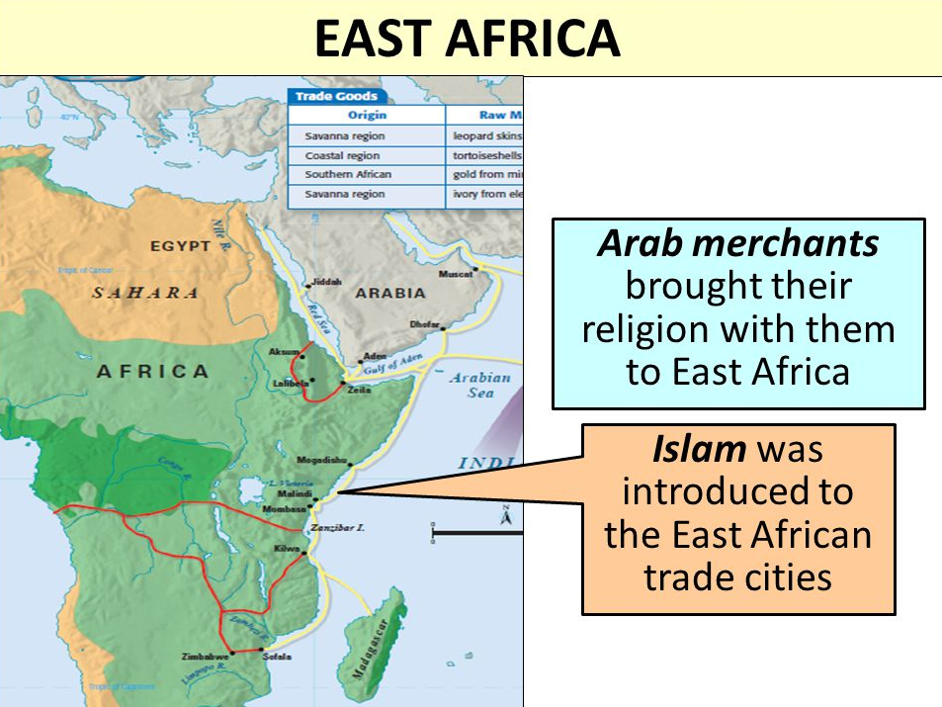

**NEGATIVE IMPACTS OF THE YAO ON THE LOCAL INHABITANTS IN MALAWI**

1. **Devastation**

* The Yao carried out raids in the Southern Region in order to obtain slaves. This caused destruction of properties in the area. Some properties were even set on fire.

1. **Instability**

* The Yao contributed to the downfall of Maravi Kindom when Yao chief Chitundu killed Karonga Sosola in the 1850s.
* The Yao also fought the Nyanja and Mang’anja in the conflict known as Mbonechi Wars.

1. **Loss of political authority**

* The Mang’anja and Nyanja lost their political authority to the Yao invaders in Southern Region.

1. **Suppression of culture**

* The indigenous people adopted Yao aspects of culture such as language, dances and initiation rites.

1. **Expansion of slave trade**

* The Yao expanded slave trade into the region from the East African coast. The Yao exported slaves from the Lake Chirwa region and the Shire Highlands to Kilwa on the East African coast.

**TOPIC TWO: THE LOMWE**

**THE ORIGIN OF THE LOMWE AND MIGRATION OF THE LOMWE**

* The Lomwe came from the area around Namuli Hill and the upper Lujenbda River in North West of Mozambique.
* It is also claimed that the Lomwe lived at a place called Nguru on the eastern side of Lake Chilwa and Mulanje Mountain.
* The lomwe entered Malawi through the southern tip of Lake Chilwa and Mulanje Mountain.
* They came to Malawi in small families at different times.
* They first settled aound Mulanje and Phalombe areas in Southern Malawi. They spread to Thyolo, Chiladzulu and parts of Zomba
* They found the Yao and Mang’anja in their new homeland.
* The sub-ethnic groups of the Lomwe people who settled in Malawi include Mihavani, Marenje, Manyawa, Nahito, Muhipiti, Nyamwelo, Lolo, Malokotera,Meeto, Likukhu, Mihekeni, Takhwani, Kokhola and Maratha.

**THE RESONS WHY THE LOMWE MIGRATED TO MALAWI FROM MOZAMBIQUE**

1. The Portuguese oppression forced many Lomwes in search of a peaceful area
2. Being British Porters and mercenaries
3. Self for employment in the tea and coffee plantations in the Shire Highlands. They also found employment in the construction of railways in the area.
4. There conflicts among the Lomwe in the 1930s which resulted an influx of the Lomwe into Nyasaland.
5. Political instability in Mozambique due to the long civil war. This forced the Lomwes to settle in the Shire Highlands permanently.

**THE FACTORS THAT INFLUENCE THE LOMWE’S CHOICE OF THEIR SETTLEMENT IN SOUTHERN REGION**

1. Availability of employment opportunities attracted the Lomwe to the Shire Highlands. The British were just developing tea and coffee plantation estates in the area. They also participated in the construction of railway lines in the region.
2. The Mang’anja were peaceful so that they mixed well with the Lomwe.
3. The stability created by the establishment of British colonial rule in the Shire Highlands meant that the area was good for settlement.

**SOCIO-POLITICAL ORGANIZATION OF THE LOMWE**

* The Lomwe entered southern Malawi in small migratory groups; they did not have a single political leader or paramount chief.
* The Lomwe were matrilineal societies. This meant that the property and title passed on to a man’s nephew. Upon marriage, the man went to live at the wife’s village.
* The Lomwe are associated with various traditional dances such as Tchopa, Likwata and Jiri.
* Tchopa was also performed for religious purposes. Before offering sacrifice in times of a dry spell, for example, the chief would organize Tchopa as part of the ceremony.

**SIMILARITIES IN THE SOCIO-POLITICAL ORGANISATION OF THE LOMWE AND THE YAO**

* Both had matrilineal societies
* Both did not have a single leader when entering Malawi

**IMPACT OF THE LOMWE ON THE INDIGENOUS PEOPLE**

The arrival of the Lomwe in southern region affected the earlier inhabitants in the following ways:

* The settlement of the Lomwe in the Shire Highlands for employment worsened land problems. The growing local population led to land shortages. The arrival of the Lomwe increased the land pressures in the southern region.
* The local people such as the Mang’anja adopted aspects of Lomwe culture such as dances, language and customs. It is difficult to distinguish the Lomwe and Mang’anja in Mulanje and Chiladzulu districts**.**

**TOPIC THREE: THE NGONI**

* The Ngoni were a product of Mfecane.
* Mfecane was used to describe the political instability in the Natal region between 1816 and 189.

**ZULU NATION AND SHAKA ZULU**

* Shaka Zulu was the son of the Zulu King, **Senzangakhona** and his mother was **Nandi** who belonged to the Elangeni clan which was under Mthetwa.
* He grew up among the Mthetwa where he became the skillful warrior in the Dingiswayo’s army.

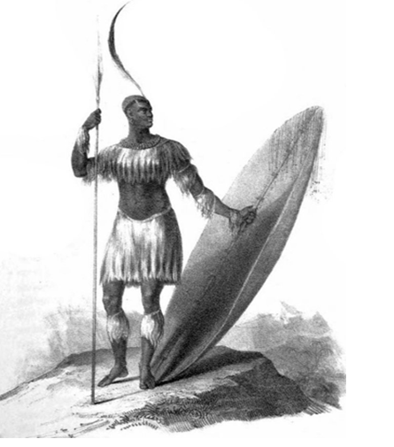Tshaka zulu

* He introduced the military tactics such as a long-hide shield that covered the whole body.
* He devised a short-stabbing spear called Assegai for close hand to hand combat. The spear could be retained and not thrown at the enemy.

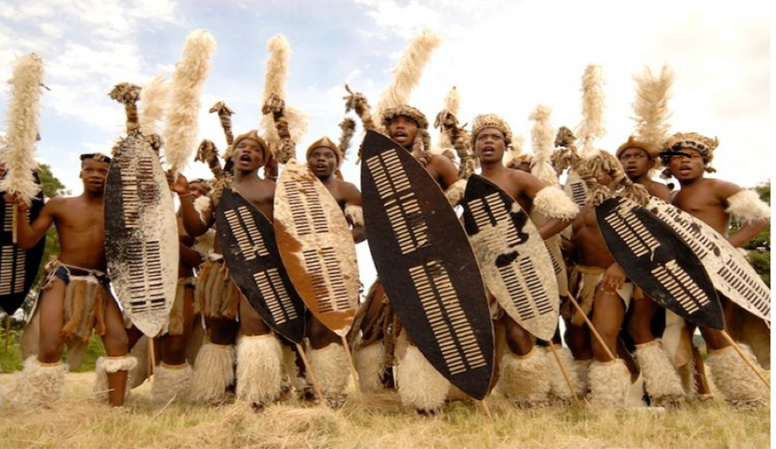

Zulu Soldiers

* When Senzangakhona died in 1816, Shaka murdered his elder brother and legitmate heir, Sigujana and became the king of the Zulu nation.

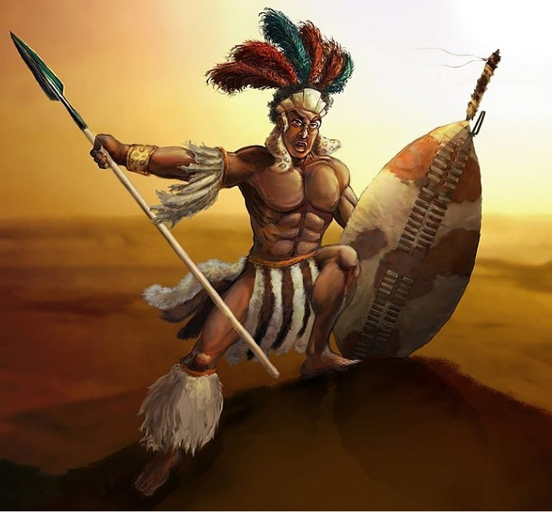 Tshaka Zulu

* Shaka was assassinated by his brother Dingane in 1828
* The three powerful chiefdoms emerged in Natal were

1. The Ndwandwe under Zwide
2. The Mthetwa under Dingiswayo
3. The Ngwane under Sobhuza

* In 1818, Zwide defeated the Mthetwa and killed Dingiswayo. The Mthetwa people were absorbed in a small Zulu chiefdom.
* Later, Zwide defeated Sobhuza and the Ngwane fled to Swaziland.
* The glory of Zwide ended with the rise os Shaka to the Zulu throne.

**MFECANE**

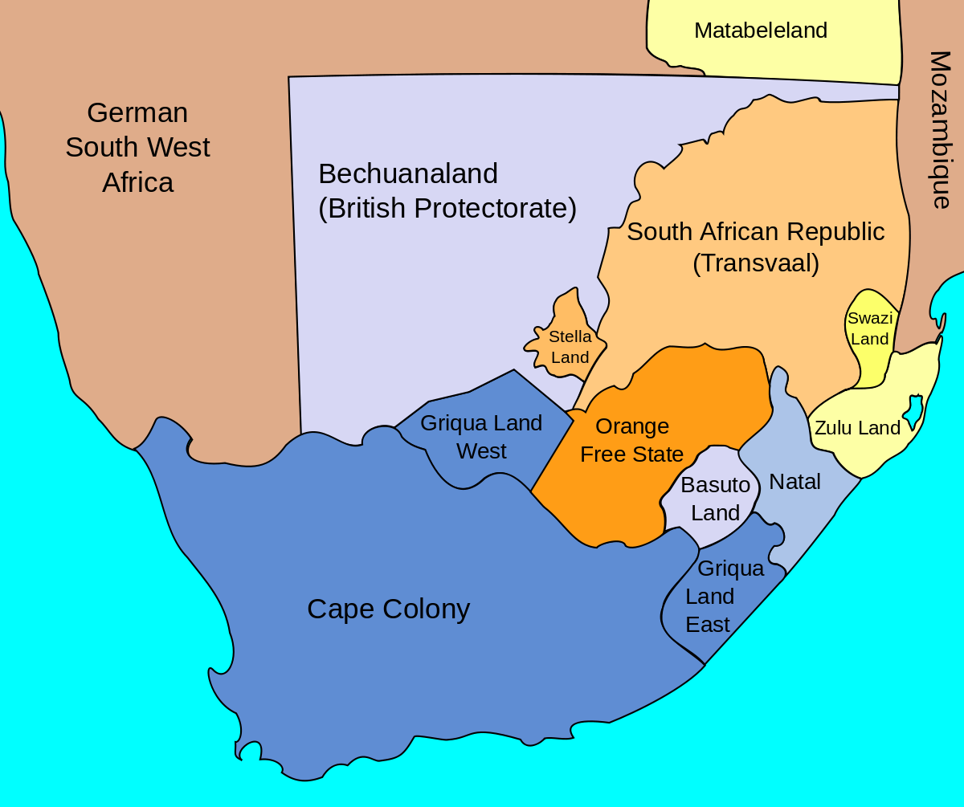

* Mfecane was the period of intertribal wars, calamity and chaos or disturbances which led many Nguni people to migrate from **Zulu land** to countries like Lesotho, Tanzania, Zimbabwe, Zmbia and Malawi. See Zulu land in the map above.
* Mfecane refers to the period of widespread chaos and disturbances in Southern Africa during the period between 1818 and 1840 caused by the Nguni from **Zulu land**.
* It also refers to the Nguni word used for wars and disturbances chich accompanied the rise of the Zulu.
* It also describes times of troubles, wars or upheavals that marked the rise of Nguni society in South Africa as a result of land scarsity occasioned by population increase.

Mfecane is defined as the period of widespread warfare, plundering, disturbances, destruction and migrations in Zululand and in some parts of South Africa. Defeated clans were forced to scatter throughout the region whereas others were forced to migrate to safer components of the region. This happened between 1816 and 1856

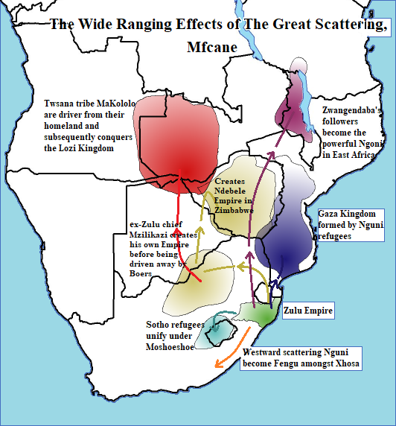

**CAUSES OF MFECANE**

1. The struggle for power especially in Kwazulu Natal. The Shaka’s military and expansionist strategy made many Nguni to leave Zululand.

The three powerful chiefdoms emerged in Natal were, The Ndwandwe under Zwide, The Mthetwa under Dingiswayo and The Ngwane under Sobhuza

* In 1818, Zwide defeated the Mthetwa and killed Dingiswayo. The Mthetwa people were absorbed in a small Zulu chiefdom.
* Later, Zwide defeated Sobhuza and the Ngwane fled to Swaziland.
* The Jere Ngoni migrated to Central Africa while the Ndebele went and settled in Zimbabwe.

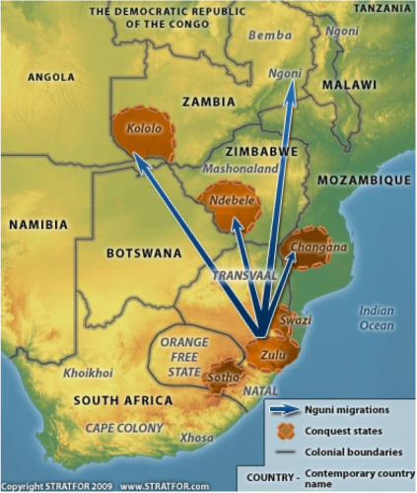

1. **The age grade military system**

* The evolution of the age grade military system led to Mfecane.
* By the introduction of this new military system, neigbouring communities had to escape from their original homestead for the safe life.
* Moreover, to get land, people had to fight for landwhih led to the creation of age regiments (amabutho)
* The feated ones had to migrate to other places in search of new lands.

1. **Trade**

* The rise of long distance trade also led led to Mfecane.
* During the 16th century, trade had developed along the east coast of Africa with the Portuguese at Gelagoa Bay.
* Trade in ivory through the Mozambique port of Delagoa had increased to new heights and the demand for ivory increased on the side of traders.
* The desire to control trade, some Nguni tribes begani to attack other tribes in order to control and to acquire more tributes
* The Portuguese wanted to trade with organized groups under powerful leaders. The Portuguese government in Delagoa Bay also traded in slaves. Black people had to leave their homes and flee to avoid being captured as slaves. This brought about unrest, conflict and destruction amongst them.
* There was also great competition for the trade in ivory where stronger groups attacked smaller groups in order to get the most ivory.
* The British government needed labourers especially after the arrival of the British settlers in 1820

1. **The influence of the Boers**

* The Eastern Expansion by the Cape Whites was also a cause of Mfecane
* Towards the end of the 18th century, there was a great desire by whites at the Cape to expand to expand to expand in the Eastern direction in oder to acquire more land.
* The advancement of Boers to South Africa led to Mfecane. Their movement into South Africa instigated shortage of land and increased population in the south east that resulted in tribal wars.
* The Boers were determined to control fertile soils in the interior and this caused more trouble in South Africa.

1. **The rise of Tshaka**

* The rise of Tshaka and his expansion policy led to the intensification of the Mfecane.
* The Zulu state under Tshaka organized instant wars of expansion against the Pondo, Mthetwa, Swazi, Zwide Ndwande and the Sotho.
* His coming into power increased the rate of Mfecane as he was interested in wars and hence defeated other tribes.
* The role played by Dingiswayo and Tshaka as the leaders of the state forced people to migrate in fear of these cruel leaders.

1. **The influence of the environment**

* The Kwazulu Natal experienced droughts and this forced people to areas which had better rains.

1. The scarsity of the grazing land for the cattle in the Zululand abnd Natal due to the increase in the population of Bantu of the Nguni- speaking group

**THE IMPACT OF MFECANE**

1. **Depopulation -** South East of South Africa became the land of death, misery and acute hardship the land interfered with human corpses and skeleton.
2. **Migration of people from South Africa to other areas.** People moved from insecurity places to secure places, for example Ndwande and Ngwane moved towards the north of South Africa.
3. **De-centralisation and separation of families-** Relatives, customs, and traditions were ruined because people of the same humanity never met due to demise and others moved to new areas.
4. **Intermarriages among the societies-** When groups moved to other places they married each other for example Hehe and Mbuga intermarried with the central societies.

**POLITICAL IMPACTS/EFECTS OF MFECANE**

1. **The formation of Boer Settlements at Natal in South Africa**- many people left the natal area during the war hence the Boers occupied the area and established their own settlements in 1800.
2. **The rise of strong leadership**- The states that survived until the period of the European colonization of some of the leadership had created outstanding armies they put up stiff resistances to European conquest.
3. **The collapse of some states in Central Africa and East Africa**- the Lozi, Rozwi and Tumbu were badly destroyed. The Nguni migration in East Africa demolished states like Yao, Mwenemutapa, Tonga, Sanga and Hehe.
4. **The formation of new empires**- These include empires of Gaza, Sena Empire.
5. **Political re**-organization- Political unity was created in such way that power was never absolute. They discouraged force of disruption because these units also created the cross-cutting alliance.
6. **Military orgaisation**- many states used the same method of fighting, for example, Nguni Kololo and Ndebele copied Tshaka’s method of fighting.Figure below shows the impis.

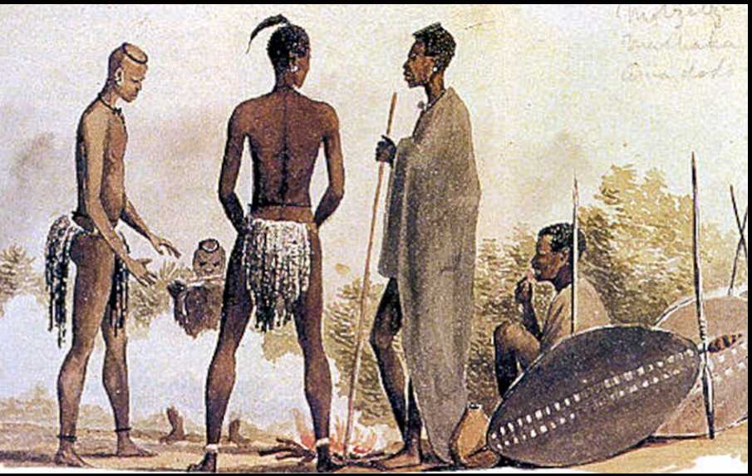

**ECONOMIC IMPACTS/EFFECTS OF MFECANE**

1. **Increased slave activities-** Ngoni and Ndebele took the captives of the war as slaves. African coastal traders were easily raided and captured people and sold them into slavery.
2. Disruption of trade along the coast of Africa.

**THE JERE NGONI**

**THE MIGRATION OF THE JERE NGONI TO CENTRAL AFRICA**

* Zwangandeba and his Jere Ngoni left Zululand after Shaka defeated Zwide of Ndwandwe at the **battle Umhlatuze.**

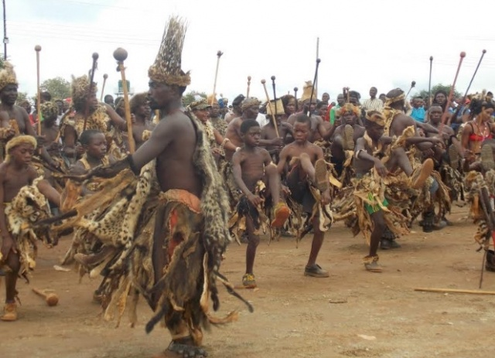

* The Jere Ngoni went northwards into Swaziland while attacking the Swazi and the Tsonga in the process.
* From Swaziland, they crossed Limpopo River and entered Mozambique where they found the Soshangane’s and Nxaba’s groups at Delgoa Bay. They stayed together until 1831 when there was conflict between the Jere Ngoni and the Shangane. Soshangane and Nxaba defeated Zwangendaba.
* From Mozambique, Zwangendaba led the Jere Ngoni to Rozwi country in Zimbabwe where they destroyed Rozwi centres at Khama and Dhlodhlo.
* One section of Zwangendaba Jere Ngoni led by Nyamazana, a female general remained behind in Zimbabwe and defeated the Rozwi. This group was later incorporated into the Ndebele. Nyamazana got married to Mzilikazi, the Ndebele leader.
* The main Jere Ngoni group led by Zwangendaba proceeded northwards and crossed Zambezi near Zumbo on 19th November, 1835 to north of Zambezi. This was the same date when M’mbelwa was born. They conquered the Nsenga of Petauke and captured Chiwere Ndhlovu in West Zambia.
* From Zambia, the Jere Ngoni entred Malawi and settled at Mabiri on 19th September, 1840. They caused a great deal of trouble to the Tumbuka and the Chewa in Malawi.
* In 1844, the Jere Ngoni left Mabiri and went to Ufipa in Tanzania after they heard that there Red Zebu cattle or long-horned cattle there in Ufipa.
* They raided the Tumbuka and the Ngoni on the way to Tanzania. They settled at Mapupo in 1845.

**THE JERE NGONI SUCCESSION DISPUTES AT MAPUPO IN TANZANIA**

* When Zwangendaba died in 1848 while at Mapupo (Fipa) in Tanzania, succession disputes broke out. The Jere Ngoni split into various groups and went to occupy various parts of East and Central Africa.
* Mpezeni the eldest son from Zwangendaba’s first wife was not crowned the king after the indunas opposed the move because Mpezeni’s mother had lost the favour with Zwangendaba over allegations that she had attempted to poison him.
* M’mbelwa was named by Zwangendaba before his death as the next king. Amidst disputes Ntabeni acted as regent to govern the kingdom while M’mbelwa was still young at the age of 8.
* The map below shows the migration of the Ngoni from Zululand

**SPLITTING UP OF THE NGONI AT MAPUPO**

The Ngoni broke up into the following groups

1. **The Tuta Ngoni**

* The leader of the Tuta Ngoni supported the crowning of Mpezeni.
* After his death, Mgayi who favoured M’mbelwa as the next king became rge regent, Ntabeni supporters went out settle on the Lake Victoria.
* The rest of the group under Mgayi decided to rei-enter Northern Malawi.
* However, Mgayi deied on the way in northern Tanzania. He was succeeded by Gwaza Jere, another senior induna.

1. **The Gwangwara Ngoni**

* After the death of Mgayi, Zulu Gama left with another group which settled at Songeya in Southern Tanzania.

1. **The Mpezeni Ngoni**

* With the Younger brother, Mpherembe, Mpezeni went southwards into the Bisa country. They proceeded to the Bembaland where the Bemba defeated them.
* The Bemba had guns which they had acquired through slave trade from the Arabs.
* Mpherembe re-entred Malawi in 1870 to join M’mbelwa . Mpezeni went on to settle in Chipata, eastern Zambia. The Ngoni of Mchinji are a subsidiary or an offshoot of the Mpezeni Ngoni.

1. **Chiwere Ndhlovu**

* He ran away with two of Gwaza Jere’s sons, namely Msakambewa and Vuso.
* His group failed to settle in Kasungu because Mwase repelled them. Mwase of Kasungu had guns which he acquired from Jumbe which enabled him to defeat Chiwere Ndhlovu’s group.
* Chiwere Ndlovu and Msakawmbewa Jere settled in Dowa while Vuso Jere settled in Ntchisi.

1. **Gwaza Jere**

* This was the main group in which Mtwalo and M’mbelwa were. They entered Malawi harassing the Ngonde in the process. They proceeded further southand stopped in the Henga Valley whee Gwaza offered leadership to Mtwalo.
* But Mtwalo declined and instead opted for his young brother, M’mbelwa. As a result, M’mbelwa was crowned king in 1855 at Ng’onga. From there, the group proceeded to the present day district Mzimba.

**WHY DID THE ZWANGENDABA NGONI SETTLE IN NORTHERN REGION?**

* The Jere Ngoni settled in northern Malawi because

1. There was god grazing land for cattle-keeping and it was free from tsetse flies.
2. There was enough land for settlement
3. The area was suitable for its water resources. The rivers provided water not only for domestic purposes but also for animals.

The map below shows the migration of the Ngoni from Zululand to Central Africa.

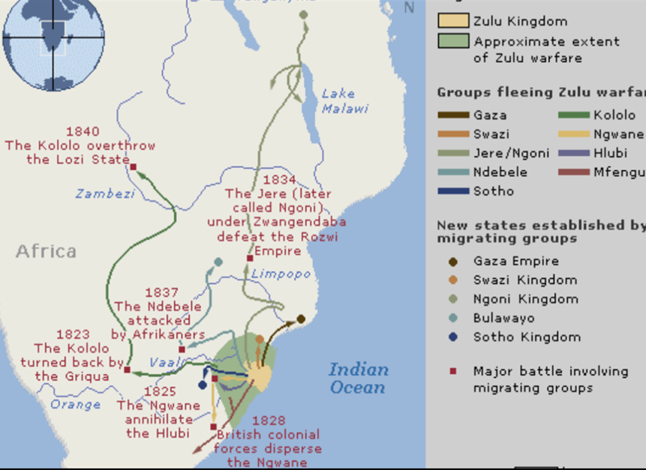

**WHY DID THE SCOTTISH MISSIONARIES ADVISE HARRY JOHNSTONE NOT TO ANNEX THE NORTHERN NGONI COUNTRY IN 1891?**

* They argued that the move would create resentment among militaristic Ngoni.

As such Johnstone promised not to extend British colonial rule in the area. The promise would base on the condition that the Ngoni should remain in the area they occupied at the time and they should stop raiding or harassing the people outside their territory.

**THE FALLING OF THE NGONI TERRITORY UNDER THE BRITISH RULE IN 1904**

* Mzimba was the last district to come under British protectorate. After a treaty with Alfred Sharpe, the Ngoni chiefs agreed to the extension of British authority into their territory on 24th October, 1904.
* Hector Macdonald derogatively called “Madondolo” by the local people became the first British Resident to administer the Ngoni affairs in Mzimba.
* The Ngoni agreed to stop raids, to obey the new and to pay tax to the colonial administration.

**THE REASONS FOR MIGRATION OF THE NGONI**

1. The defeat of Zwide forced the Ngoni to migrate northwards
2. Zwangendaba’s ambition to create his own state.
3. They were constantly looking for resources such as cattle to satisfy the group.
4. Succession disputes. After the death of Zwangendaba in 1848 at Mapupo in Tanzania, succession disputes broke out. The Jere Ngoni split into various groups and went to occupy various parts of East and Central Africa.

**THE FACTORS THAT CONTRIBUTED TO THE SUCCESS OF JERE NGONI NORTH OF ZAMBEZI**

1. Due to assimilation, the Ngoni kept adding on to their population various ethnic groups.
2. They had military superiority over the conquered tribes. The Ngoni adopted Shaka’s military techniques and maintained a regimental system.
3. The Ngoni collected tribute from the subjects by force.

**THE MASEKO NGONI**

* After their defeat by Zwide, the Ngwane escaped to Swaziland.
* In Swaziland, Ngwane Maseko and his group united with the Nsene of Nxaba.
* In 1832, Nxaba was defeated by Soshangane. After this incident, his group split into the original factions of the Nsene and the Maseko Ngoni. Nxaba took the Nsene into Zimbabwe where he and most of his men were killed in a fight with the Kolo of Sebitwane in the 1840s.

**THE MIGRATION OF THE MASEKO NGONI**

* After the defeat by the Soshangane in 1832, Ngwane led the Maseko Ngoni northwards into Zimbabwe. They crossed Zambwzi River in 1836.
* Soon afterwards, Ngwane died and was succeded by **Magadhlela**.
* When Magadhlela died, the leadership went to Ngwane’s son called **Mputa**.
* The Maseko Ngoni under Mputa re-entered Mozambique where they briefly settled at Domwe Hills just south of Dedza.
* The Maseko Ngoni settled at Domwe Hills for the following reasons

1. Domwe had enough and good grazing land
2. The local Nyanja could easily be dominated as they were militarily weak
3. The area was a good raiding ground since the local people kept huge herds of livestock.

**THE REASONS WHY THE MASEKO NGONI DEPARTED DOMWE HILS FOR MOZAMBIQUE**

* The Masekpo Ngoni abandoned the area in 1837 because they wanted to avoid conflict with the Zwangendaba Jere Ngoni. It was while they were at Domwe Hills; the Maseko Ngoni learnt that Zwangendaba’s group was coming in their direction.

**KALONGA SOSOLA AND THE MASEKO NGONI**

* By that time when the Maseko Ngoni were at Domwe Hills, the Kalonga’s headquarters was at Maere a Nyangu in Ulongwe. The Maseko Ngoni were helped by Kalonga Sosola to cross the Shire River to Mozambique.

**THE MASEKO NGONI IN MOZAMBIQUE**

* The Maseko Ngoni attacked the Yao in Mozambique forcing them into southern Malawi.

**SONGEYA IN TANZANIA**

* From Mozambique, the Maseko Ngoni proceeded to Tanzania where they settled at Songeya in 1839.
* While at Songeya in Tanzania, they lived with the Gwangwara Ngoni.
* After the death of Zulu Gama in 1858, the Maseko Ngoni and the Gwangwara Ngoni quarreled. Unfortunately, the Maseko were defeated and Mputa was killed in the fight.

**THE MASEKO NGONI AND CHIDYAONGA**

* After, Mputa was killed in the fight against Gwangwara Ngoni at Songeya in Tanzania, Chidyaonga acted as regent, as Mputa’s son, Chikuse was still young.
* Chidyaonga led the Maseko Ngoni into central Malawi around 1867. They settled in the area that extends across Dedza and Ntcheu uplands.
* Here the Ngoni frequently raided the Yao chiefs for cattle and they dominated the Nyanja.
* The uplands areas between Dedza and Ntheu was ideal settlement place for the Maseko Ngoni because of the following reasons

1. There was enough grazing land for the livestock. They settled at Domwe because it had good grazing lands.
2. The Nyanbja were willing to be under the Ngoni . The Nyanja welcomed the Ngoni with the hope that the Ngoni would protect them from the Yao slave traders like Tambala.
3. The militarily weak Nyanja dominated the Ngoni.

* By the time Chidyaonga died in 1978, the Maseko Ngoni dominated the Dedza-Ntheu area.

**SUCCESSION CRISIS AFTER THE DEATH OF CHIDYAONGA IN 1878**

* After the death of Chidyaonga, the son of **Mputa** called Chikuse succeeded him. But some people wanted Chifisi , son of Chidyaonga, to succeed. As a resut, the Maseko Ngoni were divided. Chifis was then crowned as second influential chief.
* After the death of Chikuse and Chifisi in 1891, **Gomani** succeeded his father Chikuse. On the other hand Chifisi was succeeded by his son **Kachindamoto**.
* Not pleased with the installation of Gomani, Kachindamoto attacked Gomani. After three years, Kachindamoto was defeated and he fled to **Mtakataka** in Dedza where he established his headquarters. Gomani remained at **Lizulu** in Ntcheu District.

**HOW DID THE BRITISH ESTABLISH THEIR RULE OVER THE MASEKO NGONI?**

* When the British extended taxation to the area of the Ngoni in 1891, Gomani resented his people paying tax because he had not asked for British protection.
* Goman was also against his subjects working for Europeans.
* In 1896, some people had escaped Ngoni raids and had sought refuge with the missionaries at Dombole. Gomani demanded the release of the refugees. When the missionaries refused his demand, some 27 surrounding villages were razed down. Gomani was arrested and shot dead on 27 October, 1896.
* Thereafter, effective British rule was extended over on the Maseko Ngoni Country.

**REASONS FOR THE MIGRATION OF THE MASEKO NGONI**

1. Drought Conditions. They left Zululand because of drought conditions hence they were looking for areas with better rains.
2. **They were running away from attacks.**

* They left Zululand because they were defeated by Zwide and left for Swaziland.
* They left Swaziland because After the defeat by the Soshangane in I n Mozambique, 1832, Ngwane led the Maseko Ngoni northwards into Zimbabwe
* The Masekpo Ngoni abandoned the area in 1837 because they wanted to avoid conflict with the Zwangendaba Jere Ngoni. It was while they were at Domwe Hills; the Maseko Ngoni learnt that Zwangendaba’s group was coming in their direction. In 1837, the Maseko Ngoni were defeated by the Gwangwara Ngoni at Songeya in Tanzania that made them to fled to central region of Malawi.

1. **They were looking for grazing land**. They settled at Domwe because it had good grazing lands.
2. **Succession disputes**. After the death of Gomani and Chifisi in 1891, **Gomani** succeeded his father Chikuse. On the other hand Chifisi was succeeded by his son **Kachindamoto**. Not pleased with the installation of Gomani, Kachindamoto attacked Gomani. After three years, Kachindamoto was defeated and he fled to **Mtakataka** in Dedza where he established his headquarters. Gomani remained at **Lizulu** in Ntcheu District.

**SOCIO-POLITICAL ORGANIZATION OF THE NGONI**

1. The Ngoni created a highly centralized administration with the paramount chief as the supreme political authority.

* The Paramount Chief had both judicial and military power. He was referred to as Inkosi ya Makosi (Kings of Kings) and he alone was entitled to the royal salute, **Bayethe**.
* The paramount Chief had power which was unquestionable and he was above the law.
* The paramount chief was assisted by a council of indunas at his royal court. The council of indunas that assisted the paramount chief was called **Indaba**.
* Indaba was an assembly of chiefs, indunas, nobles and village headmean that assisted the paramount chief at the royal court.
* The functions of the Indaba included the following

1. To make laws
2. To discuss military matters
3. To settle cases.

* Below, the paramount chief, there were the Makhosi or the District chiefs who all came from the Jere clan
* The function of the Makhosi or the District chiefs was to administer territories on behalf of the Inkosi ya Makosi/paramount chief.
* The Makhosi were followed by **Makosana**. The Makosana were the ward chiefs who were incharge of several villages. They werein-charge of several villages and were group village headmen.
* After the ward chiefs, came **Balumuzana or nobles** who were clan leaders. The Balamuzana were not drawn from the Jere clan. They were assimilated tribes such as Nsenga, the Shona, the Sotho and the Swazi. The function of the Balumuzana was to assist in the organization of the military.
* In case of the northern Ngoni, the Balumuzana included Chiputula Nhlane, Ng’onamo Makamo and Kampingo Sibande.
* Below the Balumuzana were the **Amakhanda** or village headmen. These stood at the very bottom of the political hierarchy. The Amakhanda were dealing directly with the local people.

1. The Ngoni practiced patrilineal system of inheritance by which property and titles were passed on to sons through the father’s lineage.
2. Socially, the Ngoni society was divided into two classes. The original Nguni were called the **Zanzi.** They were fewer in number than the captured tribes. After travelling thousands of kilometers, the Ngoni incorporated various tribal groups. All the assimilated people belonged to the **Abafo Class or Serfs**. The Abafo Class or Serfs consisted of the tribal groups such as the Nsenga, the Tonga and the Tumbuka.
3. The Ngoni created military states where they settled because of their warlike nature. The Ngoni country was divided into territorial divisions and each had its own district amy or Jaduna. Unlike the Ndebele, the Ngoni never created military barracks but soldiers were only summoned when there was need.

The military groups were referred to as Impis (army). The Impi or the army was graded into age groups. In a way, the Ngoni practiced age regimental system. All boys aged 21 and below were called Libandhla or Majaba. Basically, the term applies to grown up boys. The Madoda or men formed the centre of the military.

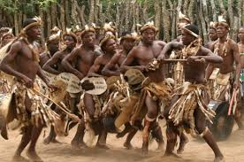

**POSTIVE IMPACT OF THE NGONI**

1. **Governance**

They introduced a centralized administration and inheritance system into the societies they occupied. Originally, inheritance among the Tumbuka was through the mother’s family. It is suggested that they later copied patrilineal system of inheritance from the Ngoni.

1. **Judicial system**

They introduced sound judicial system where cases were heard. Their courts provided a system of appeal. The conquered societies later adopted this system of courts.

1. **Protection**

The Ngoni protected the societies from slave trade. The Ngoni did not participate in slave trade in their society. Their economy depended on raids for cattle, food stuff and captives. In fact, the Ngoni measure wealth in terms of possession of cattle, wives and children.

1. **Expansion**

The Ngoni facilitated expansion of agriculture especially the Mpezeni and the northern Ngoni. They used captives to do agricultural work apart from hunting and paying tribute to the king.

1. **Culture**

The assimilated people copied Ngoni aspects of culture such as dances. The conquered people imitated Ngoni building and life styles.

1. **United people against colonial rule**

The Ngoni united people against colonial rule. For example, Gomani 1 and the northern Ngoni protested against taxation, labour and lack of markets.

**NEGATIVE IMPACTS OF THE NGONI**

1. **Destruction**

The raids pursued by the Ngoni during migration into Central Africa caused a lot of destruction to village villages and loss of lives.

1. **Displacement of people**

As they migrated, the Ngoni captured people from various tribes. These included the Swazi, the Nsenga, the Shona and the Karanga. The captives were incorporated into their groups and moved with them to their various destinations.

**Explain the social, political and economic effects of the Ngoni migration**

**The following are the effects of Ngoni invasion or migration in East Africa**

**Positive effects**

* The Ngoni invasion led to the rise on outstanding leaders to prominence. These included Mirambo, Nyungu ya Mawe and Mkwawa, who used the Ngoni military tactics to build their states.
* Many small Ntemi chiefdoms came together (united) and formed large political units under strong leaders to fight the Ngoni for example Sangu and Hehe (re-organisation).
* There was formation of new societies/tribe like the Mbunga.
* The Hehe under Mkwawa were able to resist the Germans.
* There was spread of Ngoni customs and culture for example initiation ceremonies where girls were taught sex educations and circumcision.
* It led to formation of a large Ngoni society in East Africa as they absorbed many people.
* It led to the formation of some societies by those who used Ngoni tactics for example Nyamwezi under Mirambo.
* It led to the introduction of new weapons eg. assegai, cowhides and shields.
* From the Ngoni invasion people learned how to become organised from smaller disorganised society, to well organised bigger political systems. These were to be under the control and leadership of organised, strong and efficient rulers such as the Sangu chief, Hehe etc.
* There were intermarriages between Ngoni and Nyamwezi which subsequently led to improved relationships between the invaders and indigenous people and an increased population.

**Negative effects**

* They caused the loss of lives leading to depopulation in some areas where they got warriors this was especially in southern Tanzania. This was due to the killing of people in the expansionist wars e.g. the Mariti remnants of Rugarugas killed so many people.
* They introduced military organisation and tactics to such an extent that the Ngoni lost their superiority. e.g Holoholo were able to defeat the Tuta Ngoni when they re attacked them.
* Their movement led to wider spread of devastation, depopulation and displacement of people.
* They destroyed the economy of the people of southern Tanzania when they grabbed their cattle (the Ngoni were cattle plunderers). The Ngoni invasion led to poverty, i.e. it led to the creation of the class of poor people as their property continued to be destroyed and persistently looted during the wars.
* The Ngoni led to formation of refugees who lived by plundering and killing i.e. the Mariti and Rugaruga who were later used by ambitious men like Mirambo and Nyungu ya Mawe to form their empires.
* The Tuta Ngoni on their movement northwards, disrupted the trade particularly between Tabora and Ujiji.
* There was loss of peoples’ language, culture and customs (detribalisation of people), i.e. the raids caused many people to become homeless and tribe less. This led to people losing their identity. In addition, such groups became terrorists who lived by war, plunder and hunting for ivory. They included the “Rugaruga” who began hiring their services as mercenaries to any chief willing to pay them.
* Ngoni disturbances disrupted normal cultivation leading to famine. There was widespread famine due to the scotched-earth policy of fighting circumstances, crop could neither be planted nor harvested, and people were forced to abandon farming.
* They led to insecurity since the new weapons and military tactics increased warfare and aggression in East Africa.
* The Ngoni intensified slave trade in East Africa, this was because they displaced people from their homes and so making it easy for slave raiders to catch and sell them.
* It led to increased warfare among the African societies, including those areas that had been peaceful before.

**TOPIC FOUR: MZILIKAZI AND THE NDEBELE**

* After the death of Dingiswayo in 1817, Mzilikazi’s Khumalo clan was incorporated into the Zulu. He became Shaka’s trusted general and induna to the extent that Shaka allowed him full control of a section of the Zulu kingdom.
* Being a trusted induna, Mzilikazi would be sent to carry out raids on neighbouring areas. The booty, or goods captured in war, would be surrendered to Shaka who in turn rewarded his general.

**MIGRATION OF THE NDEBELE TO ZIMBABWE**

* About 1821 Mzilikazi was sent to conduct raids on the neighbouring Sotho. He captured a lot of cattle and captives. Instead of handing over the cattle he had brought back to Shaka, he decided to keep it to himself.
* Shaka sent messengers to ask Mzilikazi for the cattle but he treated them cruelly. Next, he defeated an army dispatched by Shaka. Annoyed, Shaka finally attacked and defeated the Khumalo at Ntumbane Hill.
* As the result, in 1822, the Khumalo fled the Zululand with about 300 people northwards across the Drakensberg Mountains and settled at a place they called **Ekhupumuleni**, which means **“resting place” in 1824.** They kept on raiding the, **Ndzundza**, **Tswana** and the **Sotho**, in the process destroying villages and livestock/cattle, women and children in order to increase their numbers.. The defeated people were assimilated into Khumalo tribe. It was here that warriors nicknamed, Ndebele or Matabale, which means **“men of long shields”**
* The Ndebele abandoned Ekhupumuleni for the following reasons

1. Constant threats from the Pedi
2. Poor grazing land for their livestock because of a severe droughts
3. The need to keep distance from Shaka because his territory was still close to Zululand.

* The Ndebele abandoned the **Ekupumulen**i and moved to central Transvaal and established their capital at settled at **Emhlahlandhlela** in 1826 from where Mzilikazi raided the Tswana and Mangwato. From here they raided the areas in the northern and central Transvaal as well as Botswana and Lsotho. From the raids they got cattle and captives. It is believed that it is at this place in 1829 that Mzilikazi met Robert Moffat who ran the **Kuruman Mission Station**. The two became friends.
* **The khumalo left Emhlahlandhlela because of the following reasons**

1. **It** was also not safe for the Khumalo because it was still close to Zululand as they were constantly raided by Dingane’s (Dingane ruled after the death of Tshaka) warriors**.**
2. The Ndebele also faced fresh Kora, Khoisan, Griquas, Pedi and Rolong warriors.

* The Khumalo moved away further settling at **Egaben**i along the Marico River and drove away the Hurutshe who were living there. At this settlement Robert Moffat revisited the Ndebele and Dr Andrew Smith also visited the Ndebele for the first time. The Khumalo raided the Basotho and the Taung.
* The Khumalo were attacked by both the Griqua-Tswana force and the Boers. This forced the Ndebele to move and settle at Mosega for a permanent settlement.
* Mosega proved insecure to the Ndebele for the following reasons:

1. Numerous tribes such as the Tswana Gricua and the Kora united to counter- attack the Ndebele.
2. Dingane, who had become the Zulu leader, constantly attacked the Ndebele.
3. The Boers led by Hendrick Potgieter attacked the Ndebele in 1837 while the Ndebele warriors were away on hunting expedition. In fact, the Ndebele had previously attacked and taken away the Boer cattle and wagons.
4. Lack of adequate pastureland.

* The Khumalo had to move north into Zimbabwe.
* Before crossing the Limpopo River, they split into two groups, one led by Mzilikazi which went via Botswana to raid and the other led by Gundwane Ndiweni aand Nkulumane (heir apparent) which went through the Rozwi state.
* Gundwane went with old people, children, women and livestock. Gundwane on his way to Matebele raided and absorbed the locals such as the Rozwi, Kalanga and the Venda. This group was the first to reach western Zimbabwe and established a capital at **Nthabazinduna.**
* By the time Mzilikazi arrived with his group,Gundwane and other chiefs were now installing Nkulumane as their king. They argued that since they had started growing crops they needed a king who would lead in the first fruits ceremony and they thought Mzilikazi had died.
* Mzilikazi viewed this as rebellion and these leaders/indunas including Gundwane Ndiweni killed at Nthabazinduna or fled the kingdom.
* Nkulumane banished from Matebeleland or it is said that he was killed.
* See map of Transvaal below

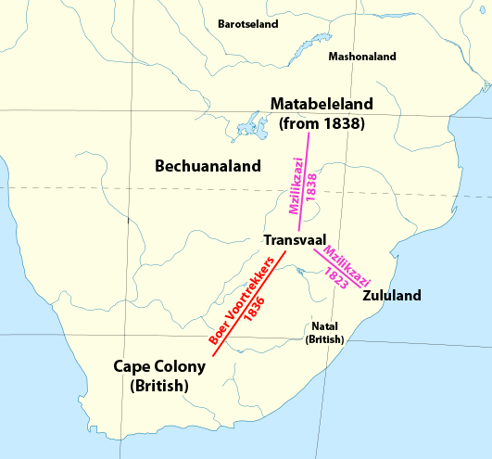

**METHODS USED BY MZILIKAZI TO ESTABLISH NDEBELE STATE**

Mzilikazi and the Ndebele used the following methods to co-opt other tribes and form the Ndebele state north of the Limpopo river:

* They demanded tribute from the local tribes
* They entered into trade relations with local tribes.
* They attacked, defeated and absorbed the Rozwi. They raided their cattle and crops
* They forbade the Europeans from selling guns and ammunition to te Shona
* They captured and killed Shona leaders.
* The people were forced to speak the Ndebele language.
* Young Shona men were conscripted into the Ndebele armies.
* The Ndebele governors were sent to control the people living in tributary areas.

**PROBLEMS FACED BY THE NDEBELE DURING THEIR JOURNEY FROM ZULULAND TO WESTERN ZIMBABWE**

1. Families were separated when the Ndebele were moving to Zimbabwe.
2. There were shortages of pastures for their livestock.
3. The Khumalo experienced shortage of food because of recurring droughts**.**
4. They were involved in many battles with different groups such as the Pedi, Rolong, Griqua and Boers.
5. Many people died during wars
6. Livestock was also lost when they were raided and some died due to tsetse flies.
7. The Ndebele homes were destroyed
8. There was rebellion by ambitious people like the Tswana and Griqua.Manby peple got sick with malaria
9. Wild animals also attacked them.
10. There was the disruption of economic activities such as trade and farming activities.
11. Many Khumalo women were taken as captive by other groups.

**DISCUSS THE REASONS FOR THE MIGRATION OF THE NDEBELE INTO CENTRAL AFRICA**

* They left the Zululand after being attacked by and defeated the Khumalo at Ntumbane Hill after He captured a lot of cattle and captives after Mzilikazi refused to hand over the cattle to Shaka, he captured from the Sotho . He decided to keep it to himself.
* They running from the constant threats from Ped while they were at Ekupumulen and constant attacks from the Zulu led by Dingane.
* They were looking for good grazing areas for their livestock
* They were being attack by the Boers led by Hendrick Potgieter attacked the Ndebele in 1837.
* The arrival of Europeans disrupted tribute from the Shona.

**SOCIAL ORGANISATION OF THE NDEBELE**

1. **The Ndebele political system was highly centralized**. The king was at the top of the political hierarchy and his position or authority was unchallenged.

* The king was both the commander -in-chief of the army and the chief judge.
* The king received tribute from the conquered people such as the Shona.

1. **The Ndebele created a military state.** They had a well-organised army with military towns around **Inyati,** the capital.

* Each town was under the control of a regimental chief or **ibutho** who was usually the king’s brother.
* The towns were further arrangded into four provinces which were under senior indunas.
* The soldiers lived in military towns but on retirement they went to settle in villages
* Themilitary groups in the Ndebele kingdom were known as Amabutho,
* The Ndebele, like the Ngoni, practiced age regimental system. In other words, the soldiers were grouped according to ages.
* The two functions of the army in the Ndebele state

1. For defence
2. For the economy of the state. The army brought back cattle, food and other items from the raids.

* All boys up to 21 years formed the **Libandhla or Amajaha.** Men formed the core defence of the Ndebele. On retirement, the soldiers would return to the village and engage in farm work. However, they could be called up for service in times of war.
* The conquered chiefs paid tribute to the Ndebele king mainly in the form of cattle. Failure to do so was regarded as rebellion and was met with punishment.

**THE SOCIAL ORGANIZATION OF THE NDEBELE STATE**

* The Ndebele social structure was highly stratified and rigid. The Ndebele social structure was based on social class system.
* The three social classes in the Ndebele society included the following

1. **The Zansi(Abezansi)**

* These were the descendants of the original Khumalo clan from Zululand and those of Zwangendaba’s woman general, Nyamazana, who had married Mzilikazi. This group formed the royal fmily. Indunas and army generals came from this class. These were the smallest group and had many priveleges.

1. **The Enhla (Abenhla)**

* This class comprised people who were absorbed by the Ndebele to present day Zimbabwe or captured on their way from Zululand. They included tribal groups such as the Tswana, the Sotho and the Venda from the Orange Free State, Transvaal boarders of Botswana. . They were numerically larger than the Zansi.

1. **The Holi (Amaholi)**

* These were the indigenous groups conquered by the Ndebele when they settled in Zimbabwe.
* This means “our slaves” and referred to the newly conquered local people such as the Karanga, the Rozwi, Nyubi, Tonga, Venda, Virwa,Nanzwa and the Shona.
* This class contributed the largest population of the Ndebele society.
* They provided labour in the kingdom. They were constantly raided by the Ndebele.
* The social stratification encouraged the lower groups to emulate and imitate the Ndebele language and culture so as to fit in and rise through the social ranks once one became fluent in Sindebele language.
* The Ndebele on the other hand adopted some cultural practice from the conquered people, for example, they adopted the Shona Mwari
* The age regimental system in the army cut across all the groups and encouraged unity.
* Marriage between social classes was discouraged but when done it was unifying factor.
* The Ndebele people were polygomus.

**FACTORS THAT BRING UNITY IN THE NDEBELE SOCIETY**

* The factors that acted as the source of unity in the Ndebele Society include the following:

1. **Sindebele language**

* The assimilated people were encouraged to speak Sindebele language, the language of the Ndebele. This was also being done to preserve their language.

1. **The Military**

* The assimilated people were involved in the military.

 The Impis

1. King’s marriages

* The king married from different tribes. The king’s wives were used as spies or informants who kept him informed about the local affairs in the state.
* However, marriage between the Zansi and other classes was restricted to maintain purity of the Ndebele ethnic group.

**THE DECLINE OF THE NDEBELE KINGDOM**

* After his death in 1868, Mzilikazi’s body lay in state for two months before it was buried at Ntombana in the Matopo Hills.
* Due to succession disputes after the death of Mzilikazi in 1868, a civil war broke out.
* Amid succession crisis, Nombante acted as a regent until two years later when Lobengula succeeded his father in 1870 after defeating his opponents.
* Due to increased foreign, Lobengula signed several treaties to protect him against European advance.
* However, the treaties led to disastrous. As more Europeans flocked into the territory, Lobengula lost monopoly over trade. Some Europeans like the missionary J.S. Moffat became agents of colonization.
* In 1893, the British South Africa Company defeated the Ndebele and took control of their territory.

**EFFECTS OF THE COMING OF THE EUROPEANS INTO MATEBELELAND**

1. It led to loss of ivory trade monopoly
2. Disruption of tribute from the conquered chiefs such as the Shona. The Shona grew arrogant due to the presence of Europeans who were considered as protectors of the Shona.
3. Some European missionaries in his territory such as John Smith Moffat acted as agents of colonization.
4. The indunas who had converted to Christianity became disloyal to the king.

**IMPACT OF THE NDEBELE ON THE LOCAL INHABITANTS**

1. They suppressed other people’s culture in Zimbabwe. The customs of the assimilated people people such as the Sotho, the Tswana, the Ngwata and the Shona were changed. They adopted Ndebele lifestyle, customs and language.
2. The raids they conducted created instability in the region. Their arrival ended an era of peaceful development in Zimbabwe.
3. They encouraged unity among the different tribal groupings. The use of Ndebele language a notion of national unity among the people.
4. They contributed to colonization of some parts of Central Africa. It was Lobengula’s treaty making with Europeans that brought immediate colonization of Zimbabwe by the British. Lewanika was forced to seek British protection partly for fear of the Ndebele warriors which led to British occupation of North Eastern Rhodesia (Eastern Zambia).

**TOPIC FIVE**

**THE PORTUGUESE FACTOR- GROWTH OF TRADE IN PRE-COLONIAL EAST AND CENTRAL AFRICA**

**EAST COAST OF AFRICA**

* The East Coast of Africa was being referred to as the Land of Zanj by the Arabs from Arabia, Persia, India and even China in the 1st Century.
* The Arabs began to establish permanent settlements along the coast and the islands off the coast during the 9th century.
* The Arabs married with the local Bantu women and gave rise to a new culture and language called Swahili.
* The Arabs and Swahili Arabs traded with the Africans in the interior and near the coast.
* The Africans supplied ivory and gold to the Arabs and Swahili Arabs in exchange for items such as cloths, beads, knives and metals from the Arabs and Swahili Arabs.
* Later, the Arabs and the Swahili Arabs moved into the interior when the flow of gold and ivory was irregular. After exchanging their goods, they **carried ivory** **and gold** to the coast with the help of **African porters**. At the coast, the porters were sold out and taken to the Middle East.
* Gold was obtained from **Mwenemutapa country** and exported through **Sofala** to Europe, Arabia and India. As a result of trade, prosperous towns developed from Mogadishu to Mozambique Island.
* By 13th Century, the control of gold trade had passed on to the rulers of Kilwa.

**THE PORTUGUESE AND THE CONTROL OF TRADE IN GOLD**

* The Portuguese came into contact with the East African coast during their search for a sea route to India at the end of the 15th century.
* During their visit, the Portuguese discovered that the wealth of the East African coastal towns came from the control of trade.
* In 1499, Vasco da Gama reported to King John about the flourishing gold trade in the region. From that time, the Portuguese were determined to break Arab monopoly of the gold trade.

m

**MAP SHOWING THE VOYAGE OF DISCOVERY OF VASCO DA GAMA**

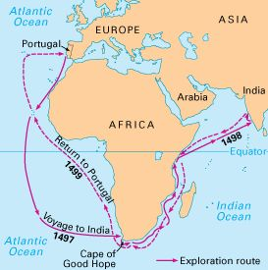

* The Portuguese defeated the Arabs and captured some coastal at Mozambique Island and Sofala from where they controlled trade in gold. The Portuguese defeated the Arabs in order to control trade in gold.
* **The Portuguese captured the East African Coast from the Arabs inorder to control trade in gold.**

**ORGANISATION OF GOLD TRADE**

* Gold was mined the local people in Mashonaland and Manicaland and presented the gold to the king Mwenemutapa who sold it with the help of middle-persons.
* The middle-persons/agents took the gold from the King and sold it to the Arabs and the Portuguese who remained at the coast.
* The agents from the King of Mashonaland and Manicaland sold it to the Arabs and the Portuguese in exchange with cloths, beads, guns, gin and wine and other goods. The Mwenemutapa received the foreign goods which he distributed to his people.
* After the arrival of the Portuguese, competition over the control of gold began. Due to this competition, the Arabs and the Portuguese moved into the interior. They took full control of gold. This made the Mwenemutapa lost monopoly of the trade in gold.
* **The Portuguese moved into Central Africa in order to take full control of gold.**

**ROLES OF THE FOLLOWING PEOPLE IN THE GOLD TRADE**

1. **Swahili-Arabs and the Portuguese**

They control trade in the East Coast of Africa. They bought gold from the Mwenemutapa from Mashonaland and Manicaland in exchange with cloths, beads, guns and gin. They came into the interior of Africa to control trade.

1. **The Mwenemutapa**

He collected gold from his subjects and sold it to the Arabs and the Portuguese through the middle-persons.

1. **The Middle-persons**

The Middle-persons collected gold from the King in Mashonaland and Manicaland and sold it to the Arabs and the Portuguese at the East African Coast.

1. **The Porters**

The Porters carried gold and ivory for the Arabs to the East Coast of Africa.

**THE ARRIVAL OF THE PORTUGUESE IN THE LAND OF ZANJ**

* The Portuguese built a fort at Goa in India after the Vasco da Gama’s visit.
* The Portuguese built Goa to act as the Portuguese headquarters for their trade in the East.
* The Portuguese wanted to have the stopping places for their ships to obtain new supplies of water and food on their way to India.
* The Portuguese decided to bring the coastal region under its control because of its valuable trade. As the result, they captured most of the coastal settlements.
* In **1505 Francisco d’Almeida** became the Portuguese representative at Goa in India. On his way to India he captured any unfriendly settlement and built forts as stopping places for the Portuguese ships en-route to India.
* **Forts** were huge buildings intended to house the Portuguese armies for defence.

**THE ARA-PORTUGUESE CONFLICT IN THE LAND OF ZANJ**

* Francisco d’Almeida catured Kilwa and later built the famous Kilwa Castle after fighting the Arabs.
* The Portuguese captured Mombasa and built the famous magnificent **Fort Jesus**. Malindi did not resist Portuguese as its Sultan was friendly to the Portuguese.
* The Portuguese also captured Sofala in 1505 and a Portuguese official was placed there at Sofala. The Portuguese used to stop at Sofala before crossing to India.
* Sofala lost its importance as an exit point to India due to its poor location. As a result, Mozambique Island became the centre of Portuguese activities.

**DISCUSS FACTORS THAT LED TO THE PORTUGUESE DEFEAT OF THE ARABS.**

* The Arabs were easily be defeated by the Portuguese because of the following reasons

1. Lack of unity. The towns were hostile to each other so they could not unite against the Portuguese intruders.
2. The Portuguese had far better weapons than the Arabs
3. The Arabs were interested in trade and neglected military defence.

**HOW DID THE ARABS PREVENT THE PORTUGUESE FROM TRADING WITH AFRICANS DESPITE THEIR DEFEAT?**

1. The Arabs befriended the local chiefs.
2. Africans preferred Arab goods which were of superior quality to the Portuguese goods.
3. The Arabs developed new routes into the interior to avoid the Portuguese so that gold was exported through Quelimane in the north.

As the result, the volume of gold that reached the Portuguese at the coast declined. This forced the Portuguese to move into the interior of Central Africa in order to control the source of gold.

**TOPIC FIVE: THE PORTUGUESE IN CENTRAL AFRICA**

1. **ANTONIO FERNANDEZ (1511-1515)**

**Aims**

1. He was sent to find out more about the gold mines
2. To win friendship of Mwenemutapa and his chiefs and to report on how best to improve the gold trade.

* He travelled between Sofala and Zimbabwe between 1511 and 1515 and he saw gold mining activities and regular markets where the Swahili traded with Africans.
* He recommended the need to develop one of the Zambezi routes and to build forts along Zambezi so as to outclass the Swahili-Arabs in an attempt to control gold trade.

**RESULTS OF ANTONIO FERNANDEZ’ RECOMMENDATIONS**

* The Portuguese placed warships on the Zambezi River to check Arab traders.
* The Portuguese established Feiras at Sena, Tete and Zumbo along the Zambezi valley.
* The Portuguese also established Feira at Dambarane, Ruanze and Masapa within the Mwenemutapa country.

1. **FATHER GONZARO DA SILVEIRA (1560-1561)**

* He was a Jesuit missionary who was sent from Goa in India to convert the king and his people to Christianity.
* He converted Mwenemutapa Negomo Mapunzagatu and 300 leading members of the royal family to Christianity.
* Afraid that they would lose trade monopoly to the Portuguese, the Arabs accused Father Gonzaro da Silveira of sorcery. They also alleged that he would bring the Portuguese to conquer the Mwenemutapa country.
* As the result Mwenemutapa Negomo Mapunzagatu ordered da Silveira’s death. He was murdered on the night of 15th March, 1561 and his body was dumped into the Msengezi River.

1. **FRANCISCO BARRETO (1569-1572)**

* The Portuguese wanted to use the death of Father Gonzaro Da Silveira as an excuse to colonise Mwenemutapa country by force.
* In 1569, Francisco Barreto to avenge the death of Father Gonzaro Da Silveira and eliminate Arab interests in the area.

**Problems faced by Francisco Barreto**

* Most f his men perished due to malaria
* Most of his men were wounded or killed in a conflict with the Tonga tribesmen.
* He failed to proceed to Mwenemutapa and he died in 1572.

**MIGUEL BERNANDES**

* He was the successor of Francisco Barreto.
* He convinced Mwenemutapa to expel the Swahili Arabs from his area.
* The result was that the King gave the Portuguese control over some gold mines and the silver mines at Tete. In return, the Portuguese paid a tax in cloth and promised military assistance.
* After some vassal chiefs rebelled against Gatsi Rutsere in 1607, the Portuguese alongside Karonga Mazura defeated the rebels. In return, the king granted the Portuguese all the gold, silver, copper, tin, iron and lead mines in his country. He also granted vast amounts of land to the Portuguese.

1. **THE MAVURA CONCESSION (1632)**

* Gatsi Rutsere was succeeded by Kapararidze who tried to expel the Portuguese out of the Mwenemutapa country in 1629. He was defeated and excuted in 1632 at Fura Mountain.
* After Kapararidze was executed, the Portuguese installed a puppet king, Mavura.
* Mwenemutapa Mavula accepted a humiliating treaty that reduced Mwenemutapa Kingdom into a Portuguese vassal.

**TERMS OF THE MAVURA CONCESSION WITH THE PORTUGUESE (1632)**

* The king was to pay tribute in form of gold to the Portuguese.
* Portuguese missionaries, traders and miners were given freedom to operate anywhere in Mashonaland.

**PRAZOS**

* The Portuguese were allowed to establish vast estates known as **prazos** on which they grew tobacco and rice.
* Prazos were vast estates established by the Portuguese in Mwenemutapa kingdom where they grew tobacco and rice.
* The prazos relied on slave labour and the prazeros or prazo holders owned an army of slaves which was used to expand territory and raid chiefdoms for slaves for the estates.

**HOW WERE THE PORTUGUESE EXPELLED FROM MASHONALAND?**

* Changamire, the Rozwi ruler destroyed Portuguese settlement at Dambarare and killed all Europeans. This forced the Portuguese out of Mashonaland in 1693.

**THE ARABS REGAIN CONTROL OF THE EAST COST OF AFRICA**

* In 1696 Seif bin Sultan of Oman attacked Mombasa and his men besieged Fort Jesus. Starved and diseased, the Portuguese surrendered in 1699.
* By 1700 Portuguese influence was confined to the Mozambique area and the trade posts in the Zambezi valley.

**WHAT FACTORS CONTRIBUTED TO THE DECLINE OF THE PORTUGUESE INFLUENCE IN CENTRAL AFRICA?**

* **Competition from the Dutch and the British**

The Portuguese faced competition from the Dutch and the British traders in India and the East Indies. This made the Portuguese to lose control o trade in the India and the East Indies to the Dutch and the British.

* **Lack of Settlers**

Being a small country. Portugal’s population was not large enough to occupy vast areas. The small population could not provide the needed manpower resource to develop Portuguese interest.

* **Reliance on ex-criminals**

Due to poor navigability and unhealthy climate, most Europeans were not willing to come to Africa. For this reason, most of the Portuguese that were sent to Africa were ex-convicts or degredados. These people were not resourceful or creative enough.

* **Insufficient economic resources**

Portugal did not have enough economic resources to administer a large empire. As such, the Portuguese concentrated on the more profitable regions like Brazil.

* **Unhealthy tropical climate**

The hot and malaria-ridded climate of Central Africa was a setback to the development of Portuguese influence in the area. Until 1854 when quinine was discovered, there was no cure for malaria. Many Portuguese settlers died prematurely due to fever.

* **Colonization by Spain**

Between 1580 and 1640 Portugal was a colony of Spain unfortunately; Spain had no need to develop Portuguese overseas interests. As a result, Portugal lost her grip on Central Africa.

* **Hostile tribes**

In the interior, the Portuguese faced resistance from the local tribes such as the Zimba and the Tonga. The Zimba, for example, attacked Tete in 1592 where they killed many of the Portuguese. In fact, the Portuguese abandoned the settlement and they returned only later once they had become certain that the fierce Zimba had retreated from the area.

* **Internal conflicts**

The Prazoros raided each other in the Zambezi area. Those defeated had no choice but to leave and their lands were taken away by the stronger prazo owners. This development weakened Portuguese position in the region as it tended to reduce the population of settlers.

* **Slave trade**

Slave trade made the work of missionaries and officials increasingly difficult. It hampered the effort to develop the trade in some parts of Central Africa. For example, Gamitto and Monteiro failed to make any meaningful progress in the Kazembe kingdom due to slave trade.

* **Destruction of settlement**

Portuguese ill-treatment of the local people caused so much resentment among Africans. For example, the Shona rebelled in 1627. Later, the Rozwi destroyed Portuguese settlements and forced them out of Mashonaland in 1893.

* **Re-establishment of Arab influence at the East Coast**

When the Arabs regained control of the East African coast, the Portuguese lost control of trade with Africans. Africans preferred to trade with the Arabs.

**POSITIVE IMPACTS OF THE GOLD TRADE ON CENTRAL AFRICA**

1. **Spread of Christianity**

The Portuguese such as Jesuit missionaries spread Christianity among some Africans. They converted some Africans in Mashonaland.

1. **Stimulation of mining**

The coming of the Arabs and the Portuguese traders into the interior of Central Africa stimulated the mining activities.

1. **Encouragement of trade**

It encouraged trade between the interior and the East African coast.

1. **Introduction of new crops**

It led to the introduction of new crops such as citrus fruits, cassava, groundnuts and maize into Central Africa. Maize was introduced from Americans.

1. **Accumulation of Wealth**

The control of trade in gold led to the accumulation of wealth especially by chiefs such as the Mwenemutapa and some middle persons. People enjoyed foreign goods brought by the Arabs and the Portuguese traders**.**

1. **Security**

African chiefs received guns as well as protection from the Portuguese and the Arabs. Guns led to the expansion and wealth of kingdoms such as Mwenemutapa.

**NEGATIVE IMPACTS OF THE GOLD TRADE ON CENTRAL AFRICA**

1. **Increased conflict**

Introduction of firearms increased warfare as property.

1. **Political interference**

The traders interfered with the running of African kingdoms. Different traders competed to win the monopoly of trade in gold. In an attempt to gain more mining and trade privileges, the Portuguese began to support chieftaincy candidates of their choice in the Mwenemutapa kingdom. Often this disturbed traditional succession processes.

1. **Participation in slave trade**

Gold was taken to the coast by Africans porters. Usually the porters would then be sold out as slaves at the coast. Some Portuguese participated in slave trade which caused suffering to the Africans.

1. **Depletion of African resources**

Huge gold deposits were used up as a result of centuries of mining. Also, the people sold out as slaves were a vital human resource. If these resources were left untapped, they would have been used towards economic development in the region.

**TOPIC SIX**

**THE MISSIONARY FACTOR IN MALAWI- ISLAM**

* **Islam became the first foreign religion to be introduced in Malawi**

**THE SPREAD OF ISLAM TO MALAWI**

* Islam was spread by the Swahili- Arabs into Malawi through the trade contacts with the local people in Malawi in the 19th century.
* The Swahili-Arabs came and settled in the interior to direct trade activities. They bought slaves and ivory from the interior in exchange with clothes, guns, silver and beads.
* The Swahili-Arab settlements were strategically located on trade routes to the East coast.
* Lake Malawi provided an effective means of transport. In fact Nkhota kota was an important port which was frequently visited by the Arab traders from the East Africa coast.
* The other districts that fall under Musllim influence in Malawi apart from Nkhota Kota are Mangochi, Zomba, Chiladzulu and Blantyre.

**WHY ISLAM FIRST MADE ITS IMPACT ALONG THE LAKESHORE REGION OF MALAWI?**

* Thus for a long period Islamic influence dominated the lake shore region of the country because of the following reasons:

1. The Swahili-Arab traders such as Jumbe and Mlozi settled along the lakeshore areas.
2. Influential Yao chiefs such as Mponda and Makanjira were located on the southern lake shore region.

**NB:** The relocation of the Swahili-Arabs into the interior helped to spread Islamic influence among the local people.

**JUMBE**

* Salim bin Abdallah came to Nkhota kota around 1840 to trade in ivory and slaves.
* He was given land by Matenga Chauzi to build his settlement.
* He became so powerful that he made himself the Sultan of Marimba and assumed the title of Jumbe (governor).
* He used his power and influence to spread Islamic influence among the Chewa of Malenga in Nkhota Kota.
* Nkhota kota became the firsty district to fall under Islamic influence in Maawi.

**HOW DID THE JUMBE’S ACTIVITIES HELP TO SPREAD ISLAMIC INFLUENCE IN NKHOTA KOTA?**

1. He encouraged the local rulers and local people to adopt Islam.
2. He sent sons of the local chiefs to Zanzibar where they trained as Mwalimu or Muslim teachers. This increased the number of Islamic teachers in the area.
3. He also offered Arabic literacy to young people.
4. His character contributed to the spread of Islam in the area. Being a generous and good leader, people eagerly followed. Moreover, he carried out slave raids in distant places such as Nkhata Bay and not in the neighbouring villages.

**FACTORS THAT FACILITATED THE SPREAD OF ISLAM AT NKHOTAKOTA**

1. It was important port which was frequently by Muslim Arabs from the coast.
2. Due to its large population, Nkhota Kota was a good ground for the spread of Islam.
3. Muslim preachers such as Sheikh Mkwanda often visited the town from his home in Salima. As a result, Nkhota Kota became an important Islamic centre.

**MLOZI**

* Mlozi settled at Mpata in Karonga around 1880.
* He made himself the Sultan of the Ngonde in 1887.
* Because of his notious slave raids, he ran into conflict with the African Lakes Company and the British who defeated him in 1891. He was tried by the Ngonde chiefs and was hanged.

**REASONS WHY ISLAM DID NOT MAKE AN IMPACT IN KARONGA**

1. Mlozi did not stay long at Karonga before he was killed.
2. Poor relations with the Ngonde prevented the spread of Islamic influence in the area.
3. There was absence of traditional elements similar to Arabic customs.
4. The area was less populous than Nkhota Kota.

**THE YAO**

* The Yao became the first ethnic group in Malawi to adopt Islam.
* It is claimed that Makanjira, Mataka and Jalsi were the first Yao chiefs to embrace Islam. This was followed by their subjects.
* The mass conversion of the Yao to adopt Islam occurred in 1870.

**Why were the Yao the first tribe to adopt Islam in Malawi?**

This was due to trade contacts with the Muslim Arabs by 1860s.

**WHAT FACTORS CONTRIBUTED TO THE SPREAD OF ISLAM AMONG THE YAO?**

1. **Desire for economic enhancement**

* The Yao adopted Islam with the hope to strengthen economic ties with the Swahili-Arabs.

1. **Yao culture**

* Yao’s initiation ceremonies and sadaka were found in Arabic culture and so they were only Islamic. The new religion appeared not to bring strange elements in the Yao society.

1. **Traditional religious beliefs**

* The traditional religious beliefs of the Yao through Lisoka or ancestral spirits while worshipping “Mulungu” were similar to some Islamic teachings.

1. **Social status**

* The Yao chiefs adopted Islamic as a way of promoting their status in society. Chiefs like Makanjira and Mataka adopted Islam as a means of modernizing their society.

1. **Interest in Arabic literacy**

* The Yao were interested in acquiring knowledge of Arabic script so that they should be able to read or write Arabic script. This would enable them to communicate effectively with their Arabic trade partners.

1. **Emergency of paramount chiefs**

* Some chiefs sought to extend their authority over wide areas during the late 19th century. This meant extending political and ritual control over several villages. Such chiefs often adopted Islam as a superior religion to the traditional one for their authority to be accepted.

1. **British colonial rule**

* The establishment of British colonial rule in 1891 triggered mass conversion of the Yao to Islam. Because the British stopped slave trade, the Yao lost their economic authority. In order to regain their influence, the Yao strengthened their relationship with the Arabs. As a form of resistance, they turned to the spread of Islam.

1. **Efforts of Muslim missionaries**

* The Muslim missionaries helped the spread of Islam as they worked along the lakeshore region of the country.
* Besides preaching, they helped convert people to Islam through sending young men to East Africa to train as Mwalimu and distribution of Islamic literature.
* The most knowm muslism missionaries were

1. Sheikh Abdallahbin Hajj Mkwamba
2. Sheikh Tabit Muhammad Ngaunje.
3. Adul Kahari Kapalasa.

**How did the wandering Muslim missionaries contribute to the expansion of Islam during colonial period?**

They helped convert people to Islam through sending young men to East Africa to train as Mwalimu and distribution of Islamic literature

1. **Islamic brotherhood**

* Islamic brotherhoods of Quadriya and Shadhriya competed for converts which increased the number of Muslims. Their competition helped to expand Islam in the country especially in the 1920s.

**IMPACT/INFLUENCE OF ISLAM ON PEOPLE’S WAY OF LIFE IN MALAWI**

The following are the positive impacts of Islamic culture on the local people’s way of life in Malawi**.**

1. **Architecture**

* There is presence of mosques almost everywhere in the country with the introduction of Islam.
* The locals copied Arabic building style such as dome-shaped buildings and fenced houses.

1. **Dressing**

* People copied Arabic dressing of robes and head bands or caps locally known as **mzuri.**

1. **Conversion to Islam**

* The local people abandoned traditional beliefs and adopted Islam.

1. **Literacy in Arabic**

* Establishment of special Islamic schools enabled some learners to speak and write the Arabic language.

1. **Cultural enhancement**

* Islam did not discourage all traditional practices of the Yao. Instead its teachings served to enhance cultural practices such as polygamy, funeral rites and circumcision.

**TOPIC 7 CHRISTIANITY IN MALAWI**

**DR DAVID LIVINGSTONE**

* Dr David Livingstone was born on 19th March, 1813 at Blantyre in Scotland.
* He entered Glasgow Medical School where he qualified as a doctor.
* Initially he intended to practice medicine in China but the outbreak of the Opium War discouraged him.
* Livingstone was a humanitarian and was influenced by an abolitionist, **T.F. Buxton**, who condemned slavery.
* After meeting with **Robert Moffat** from Kuruman in South Africa, Livingstone decided to come to Africa as a missionary.

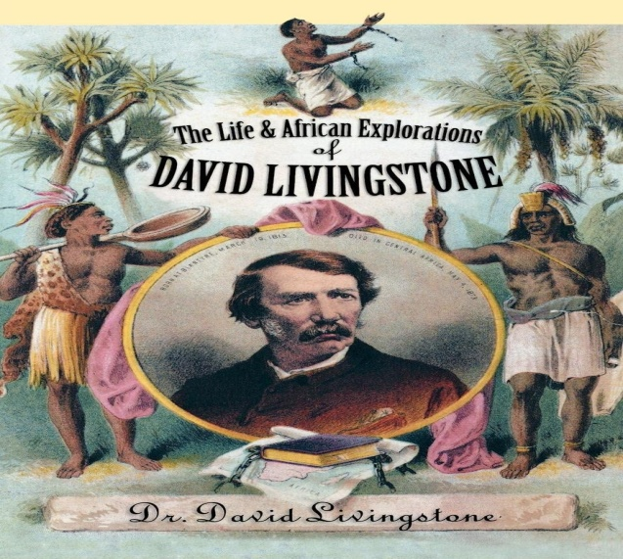

**DAVID LIVINGSTONE: THE MISSIONARY**

* Dr David Livingstone set for Africa under the auspices of the London Missionary Society on 4 December, 1840.
* He joined Robert Moffat at Kuruman in 1841.
* He married Mary, the daughter of Robert Moffat in 1845.
* Besides the London Missionary Society, he received financial support from his rich friends, William Cotton Oswell.

**AIMS/OBJECTIVES OF DR DAVID LIVINGSTONE’S MISSIONARY WORK**

1. To spread Christianity in Africa
2. To promote legitimate trade in order to suppress slave trade
3. To introduce western education in Africa.

**ACHIEVEMENTS AND FAILURES OF DR DAVID LIVINSTONE AS A MISSIONARY**

* He opened a mission station at Mabotsa and Kolobeng in 1847. However, the mission of Kolobeng was closed due to drought.
* However, he failed to open a mission station in the Kololo country because the friendly King Sebitwane died of pneumonia shortly after his arrival.

**EXPLORATION OF AFRICA**

**MAJOR EVENTS UNDERTAKEN DR DAVID LIVINGSTONE BETWEEN 1847 AND 1841**

* He discovered Lake Ngami in August, 1849.
* He met the Kololo King Sebitwane in 1851 where he was warmly received.
* He failed to open a mission station in the Kololo country because the friendly King Sebitwane died of pneumonia shortly after his arrival.
* He saw the plight of slave caravans for the first town in the Kololo country.
* It was the plight of slave trade that made Dr David Livingstone to end slave trade by replacing it with legitimate trade.

**STRATEGIES USED BY DR DAVID LIVINGSTONE TO OPEN UP CENTRAL AFRICA**

* He opened books about Central Africa which enabled Europeans to be aware about the geography. He also exposed the evils of slave trade. His writings awakened European interest in the region.
* He made public and private lec tures in Britain about Africa. In fact, it was after a lecture at Cambridge University that the idea of the Universities Mission to Central Africa (U.M.C.A) was born.
* He made special appeals to business persons to open up trade in Central Africa. The result was the formation of the African Lake Company in 1878.

**DR DAVID LIVINGSTONE AS AN EXPLORER**

* After, he failed to open up the mission station and saw the plight of slave trade in the Kololo country, Dr David Livingstone decided to find a route into the interior in order to open up Central Africa to Christianity and Civilization.

**DR DAVID LIVINGSTONE’S FIRST JOURNEY (1852-1856)**

**Aim of Dr David Livingstone’s first Journey**

* Dr David Livingstone wanted to explore the Zambezi River.

**Discoveries and Achievements of Dr David Livingstone during his first journey**

* He sailed to Linyati, the capital of the Kololo in 1852 where he saw the incidences of the slave trade that revived his earlier plans for to spread Christianity and legitimate trade in the area.

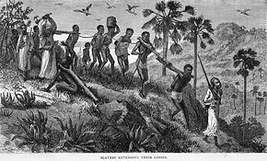

* Sekeletu, the new Kololo king gave him twenty-seven porters and left for Luanda in the hope of finding a trade route with the west coast.
* After months of travel, Livingstone returned to Linyati.
* In 1853, he reached the western coastal region of Luanda.
* In 1855, he discovered Zambezi falls which was called by native “Smoke That Thunders” and which Livingstone named Victoria Falls after Queen Victoria.
* By 1856, Livingstone had gone across the continent from west to east, arriving at the coastal region of Quelimane in what is present day Mozambique.
* He reached England in 1857 and published his book called **Missionary Travels and Researches in South Africa.**

**PROBLEMS FACED BY DR DAVID LIVINGSTONE DURING HIS FIRST JOURNEY**

1. Heavy rains
2. High fever and dysentery and dense forests which dashed his hope for the development of a large trade route to west coast of Africa.
3. The presence of the slave trade in the Kololo Country.

**RESULTS/OUTCOMES OF DR DAVID LIVINGSTONE’S FIRST JOURNEY**

* Back in England, he published the Missionary Travels and Researches in South Africa. The book was well-publicized so that thousands of copies were sold within a short period.
* He made a number of public lectures. The famous of all was made at Cambridge University, which ended with “**I go back to Africa to make a path for commerce and Christianity. Do you carry out the work I have begun. I leave it with you.”** The result was the formation of the Universities Mission to Central Africa”

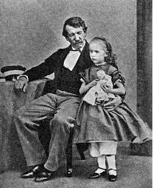

**WHAT WAS LIVINGSONE’S AIM FOR HIS SECOND JOURNEY TO AFRICA (1858-1864)?**

* The aim Livingstone’s journey was to explore the Zambezi River if it was navigable.

**LIVINGSTONE’S SECOND JOURNEY (1858-1864)**

* After its disapproval of his activities between 1853 and 1856, Dr David Livingstone resigned from the service of the London Missionary Society in 1857.
* During this second journey to Central Africa, the British Government funded his expedition.
* He reached Quelimane in May, 1858.
* From Quelimane, he went to the Zambezi where the UMCA had arrived. He accompanied the UMCA Missionaries to Magomero.
* From Magomero, Dr David Livingstone explored the western shores of Lake Nyasa up to Nkhata Bay.
* As he travelled from Magomero to Nkhata Bay, he witnessed the work of the Yao slave dealers and the Ngoni raids; burnt and deserted villages.
* Meanwhile, another steamship called Lady Nyasa had arrived together with his wife and other U.M.C.A missionaries. Sadly, his wife died of malaria on 27 April, 1862. She was buried at Shupanga.
* From Nyasaland, he explored the Ruvuma River hoping to find a better route to the interior but with no success.
* Finally, he was greatly disappointed with the withdrawal of the U.M.C.A to Zanzibar.
* Using the lady Nyasa, he crossed the Indian Ocean to Bombay in India. From there, he went back to England in 1864 and spoke out against slavery. He then wrote another book, the “**Narrative of an Expedition to the Zambezi and its Tributes”. In this book, he wrote about his use of quinine as a malarial remedy and theorized about the connection between malaria and mosquitoes.**

**LIVINGSTONE’S THIRD JOURNEY (1866-1873)**

**Aim: To explore the source of the Nile River.**

* The British Government decided not fund his expedition because it was felt that the previous expedition had not yielded much.
* With financial support from his friends and sales from his book, he started off to Africa in 1866 to explore the source of the Nile River.
* He eventually ended up in the village of Nyangwe where he witnessed a devastating massacre where Arabic slave traders killed hundreds of people.
* From Zanzibar, he proceeded to Chipata through the Ruvuma River.
* In January, 1867 he lost his medicine box.
* He travelled farther and explored Lakes Bangweulu and Lake Mweru.
* With the help of a **Swahili explorer,** **Mohammad Bogharid**, he travelled eastwards and met Henry Morton Stanley **at Ujiji on 10th November, 1871**.
* H.M. Stanley was sent by the **London Daily and** New **York Herald to find Livingstone fearing he might have died. Upon seeing him, uttered the now-well- known words, “Dr Livingstone, I presume?”**
* From Ujiji, Livingstone and Stanley explored the north end of Lake Tanganyika but they could not find the source of the Nile River.
* From there, they travelled to Tabora where Stanley left him on 14th March, 1872.
* On 1st May, 1873 Livingstone died from dysentery and malaria/fever at **Chitambo Village near Lake Bangweulu in North Rhodesia (Zambia)** where his heart was buried under a tree. His servants, **Susi** and **Chuma** together with a free slave named **Jacob Wainwright** carried the body to the British Consul at Bagamoyo. The body was then shipped to England where his remains were buried at West Minister Abbey on 18th May, 1874.

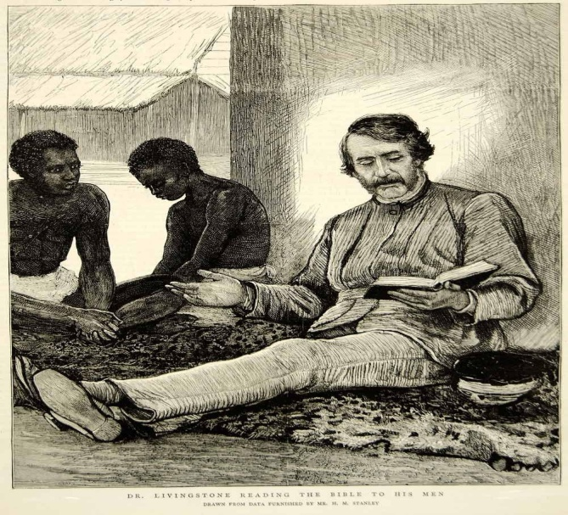

Dr Livingstone preaching the word of God

**EARLY CHRISTIASN CHURCHES IN MALAWI**

* The Christian missionary work in Malawi was pioneered by Protestants.
* The first to responds to Livingstone’s appeals for Christian mission work was the Church of England (Anglican- The Universities Mission to Central Africa).
* In the mid-1870s, they were joined by the Presbyterian churches from Scotland (Free Church of Scotland- Livingstonia Mission and the Established Church of Scotland- the Blantyre Mission).

**THE UNIVERSITIES MISSION TO CENTRAL AFRICA (U.M.C.A)**

* In response to Livingstone’s appeal at Cambridge University in 1867 where Livingstone said, “**I go back to Africa to make a path for commerce and Christianity. Do you carry out the work I have begun. I leave it with you.”** ,the members of the Anglican Church from the Universities of Oxford, Cambridge and Durban established the U.M.C.A.
* The U.M.C.A left England under the leadership of Bishop Charles Fredrick Mackenzie. The missionaries reached the mouth of Zambezi River to the Shire River.
* On Livingstone’s recommendation, they travelled to the Shire Highlands where the Mang’anja people were under constant attacks from the Yao slave dealers.

**MAGOMERO MISSION**

* On 19th July, 1861 they set up a mission camp at Magomero in Chiladzulu.
* A Mang’anja Chief, Chigunda, offered land for a mission station close to his village.
* The site was on a slave trade route which the missionaries would assist in fighting slave trade. It was also well located because of its nearness to the lake as a route up north.
* However, the missionaries ran into conflict with the Yao slave raiders when they offered support to the Mang’anja. For a time, the Yao and the missionaries engaged in armed conflicts known as the Ajawa Wars.
* The Missionaries also lacked food and medical supplies. Months later, Henry Burrup and Bishop Mackenzie died due to malaria.

**PROBLEMS FACED BY MISSIONARIES AT MAGOMERO**

1. Yao Slave raiders who were raiding the Mang’anja.
2. Lacked food and medical supplies
3. High Malaria/Fever attacks.

**TRANSFER OF UMCA TO CHIBISA VILLAGE IN LOWER SHIRE**

* Due to the problems UMCA faced at Magomero, the mission was transferred to Chibisa Village among the Kololo in Lower Shire in 1863 under George Tozer as new bishop.
* Problems at Chibisa Village

1. The area was sparsely populated
2. The Kololo too caused problems to the missionaries.

**TRANSFER OF UMCA TO ZANZIBAR**

* Due to the problems faced at Magomero and Chibisa Village, Bishop Tozer transferred the UMCA to Zanzibar in 1863.
* The missionaries built a settlement for freed slaves at Mbweni. After the closure of the Zanzibar slave market in 1873, the missionaries acquired the place and built a fine Cathedral at the location of the slave market.

**TRANSFER OF UMCA FROM ZANZIBAR TO LIKOMA ISLAND**

* The U.M.C.A returned to Malawi under the leadership of William Percival Johnston in August, 1885 and built its headquarters at Likoma Island.
* **WHY WAS LIKOMA SUITABLE FOR A MISSION STATION?**

1. Its location was safe from hostile tribes and slave dealers.
2. It would be easy for the missionaries to evangelise both sides of the lake
3. They would get assistance from the Scottish missionaries at Bandawe.

* Missionary workwas facilitated mostly by their ship Chancy Mapples which was launched on 17th September at Matope. The ship served as a link between stations on both sides of the lakes. The ship also acted as a floating teacher training college.
* The UMCA mission built the St Peter’s Cathedral at Likoma. The mission expanded from Likoma to Nkhota Kota, Malindi, Mangochi and Zomba and many other places on both sides of the lakes.

**THE LIVINGSTONIA MISSION**

* The Free Church of Scotland came to Malawi as Livingstonia Mission in 1875.
* The Free Church of Scotland was named Livingstonia Mission in the memory of Dr David Livingstone.
* The Free Church of Scotland was led by Captain Edward Young upon its arrival in Malawi in 1875 and his deputy Dr Robert Laws.

**MAP OF MALAWI SHOWING MISSION STATIONS OF LIVINGSTONIA MISSION**

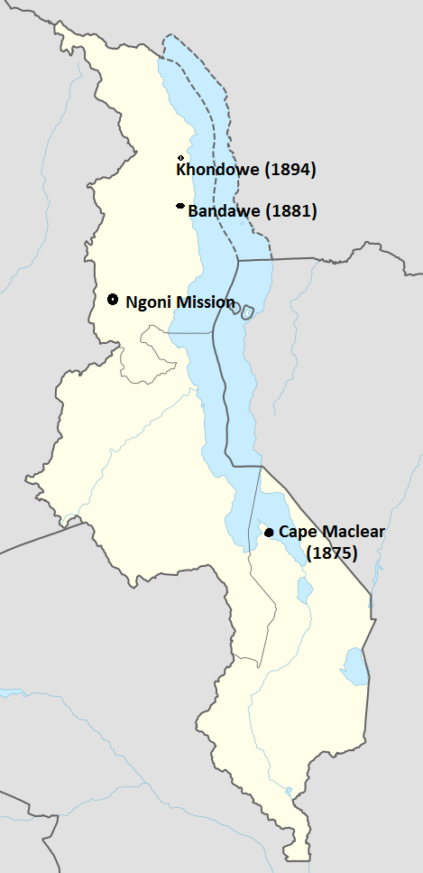

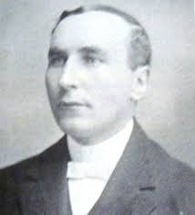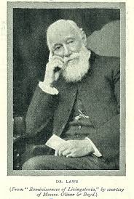

**Edward Young Dr Robert Laws**

**Positive impacts of the Free Church of Scotland at Cape Maclear**

1. Provision of education

* The missionaries opened school at the station and its first teacher was Albert Namalambe.
* In 1876 four Africa teachers from Lovedale in South Africa joined the Mission and these included

1. William Ntusane Koyi
2. Mapasa Ntintili
3. Shadreck Ngunana
4. Isaac Wauchope

* William Koyi played an important role in spreading Christianity into the northern Ngoniland in the early 1880s.

1. It spread Christianity among the people in the area.

**Problems faced by Free Church of Scotland at Cape Maclear**

* The area was sparsely populated and therefore not suitable for evangelization.
* Malaria was a threat to the lives of missionaries
* Lack of adequate land for agriculture
* The Yao boycotted the mission except refugees fleeing slave raids. Since the missionaries condemned slave trade, the Yao regarded missionaries as a threat to their economic way of life.

**FREE CHURCH OF SCOTLAND AT BANDAWE (1881)**

* In 1881, Dr Robert Laws moved the mission from Cape Maclear to Bandawe in 1881.
* Bandawe proved to be a favourable ground for mission work as compared to Cape Maclear.

**Why was Bandawe a suitable place for the free church of Scotland?**

1. The area was free from slave trade.
2. The dense population of the area was good for the spread of Christianity. As a result of indentified Ngoni raids during this period, many Tongas had settled around Bandawe in 1875.

**WHY DID THE TONGA WELCOME THE MISSIONARIES AT BANDAWE?**

1. The Tonga ccepted Christianity at Bandawe because it acted as protection from the constant Ngoni raids from Mzimba district. In other words, the Tonga eagerly welcomed Christian missionaries in the area because they regarded missionaries as allies against the Ngoni. Many of the Tonga had just fled the Ngoni attacks in 1875 and had settled around the area.
2. The Tonga wanted to benefit from the education and technical skills offered by the missionaries. The Tonga ha quickly realized the value of western education. It enabled them to enter them to enter paid employment in the Shire highlands where plantation agriculture was developing. Most of the Tonga took up jobs as clerks, interpreters, foremen which were more rewarding than manual work in the fields.

**THE NGONI MISSION (NJUYU) (1882)**

* There were two reasons why it was difficult to infiltrate the Ngoni territory and these included

1. This was due to the warlike nature of the Ngoni society
2. Christian teachings condemned their cultural practices such as beer drinking and inheritance of a deceased brother’s widow.

* Despite the Ngoni’s resistance to Christianity, **Dr Robert Laws** was determined to take mission work to the northern Ngoniland.
* In 1882, **William Koyi** went to Njuyu to negotiate with the Ngoni. He was followed by **Dr Elmslie** who was sent to start mission work despite that the Ngoni forbade any missionary teaching in Ngoniland.

**Reasons why the Ngoni no longer resist missionary work in their territory in 1880s**

1. **The balance of power steadily shifted against the Ngoni**. In contrast to 1850’s, the Ngoni warriors were no longer successful as they had been previously. The Ngoni lost confidence in their military**.**
2. **The subject people increasingly caused unrest in the Ngoni country.** There were sporadic rebellions from the Tumbuka and the Tonga.
3. **Tonga Rebellion, 1875**

* In 1875, Tonga captives fled from Mabulabo and Mzukuzuku to Chintheche and Bandawe ares led by Kazizwa. The Tonga were repelled by Ngoni Impis but the Ngoni still raided the Tongaland.

1. **Henga-Nkhamenga Rebellion, 1879**

* The Tumbuka of Henga and Nkhamanga revolted in 1878.
* The Ngoni with the assistance of Mwase Kasungu’s gunmen successfully crushed the revolt in 1880.
* In the fight, Mjuma, the eighth Chikulamayembe got killed. The rebelled escaped northwards and settled at Kapolo in Karonga.

1. **Baza Dokowe Revolt, 1880**

* It was alleged that Baza Dokowe Nyirongo has refused to hand over ivory. In response, the Ngoni watrriors encircled the Hora Mountain where Nyirongo and his followers had claimed. Hungry and thirsty, Baza’s followers climbed down where many of them were slaughtered. Baza Dokowe Nyirongo escaped to Kasungu.
* The Ngoni hoped to gain material benefits and prestige from their association with the white missionaries in their area.
* The 1885-1886 dry spell placed the Ngoni under panic. After, Dr Elnslie held mass prayers, rains at last fell and this “miracle” impressed M’mbelwa so much so that he allowed the missionaries to work anywhere in his country.
* The first covert in Ngoniland was Mawelera Tembo of Hoho Village. Despite this development, missionary progress remained slow. By 1892, for example, there were only eleven converts in the whole of Ngoniland. Later, mission work was extended to Ekwendeni in 1889 and Hora in 1893.

**IMPACTS OF FREE CHURCH OF SCOTLAND MISSION AT BANDAWE**

* It brought education to the area.
* It brought Christianity in the area.
* It brought protection to the Tonga people againstthe Ngoni attacks.

**THE KHONDOWE MISSION (LIVINGSTONIA)**

* 1n 1894, Free Church of Scotland was transferred the mission headquarters from Bandawe to Khondowe in Rumphi District.
* The mission was transferred from Bandawe to Khondowe because of frequent malaria attacks at Bandawe.

**IMPACT OF LIVINGSTONIA MISSION AT KHONDOWE**

* It brought education in the area. Dr Robert Laws established the Overtone which offered various skills such as carpentry and brick -lying. It also brought evangelists, teachers and nurses. Most of its graduates were later to play important roles in history, not only Malawi but elsewhere as well
* It brought medical facilities in the area. It is renowned for its medical work offered at the Gordon Memorial Hospital.

**THE BLANTYRE MISSION**

* The Established Church of Scotland sent the Blantyre Mission led by Henry Henderson to Nyasaland in 1876.
* The Blantyre Mission was officially established on 23rd October, 1876 in Chief Kapeni’s area in Blantyre.

**WHY WAS CHIEF KAPENI’S AREA A SUITABLE PLACE FOR BLANTYRE MISSION ESTABLISHMENT?**

The area was suitable for missionary work in the following ways

1. The cool climate of the area was good for European settlement.
2. It was close to the Shire River for transport.
3. It would be easy to work against slave trade which the Yao carried out in the area.
4. It would help the Mangochi Yao against Kololo and the Maseko Ngoni attacks in the area.

**PROBLEMs FACED BY BLANTYRE MISSION IN CHIEF KAPENI’S AREA**

1. The Machinga Yao frequently raided the Mangochi Yao for the slaves in the area.
2. The area was facing threats from the Kololo and Maseko Ngoni
3. The missionaries were assigned lacked of leadership skills
4. The missionaries interfered in local affairs which damaged their reputation at home. The missionaries acted as judges in local cases. For instance, at one time they even executed African offenders.

* The progress began with the arrival of Reverend Clement Scot when he took over the leadership of the Blantyre mission.

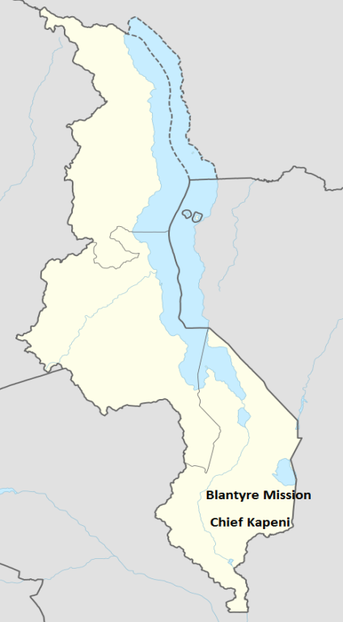

**THE DUTCH REFORMED CHURCH**

* This was the mission that started by the Protestants from Holland. These were the Dutch. Holland was predominantly Protestant.
* The Dutch (Boers) were the first Europeans to settle in South Africa under the leadership of Jan Van Riebeck on 6th April, 1652.
* The Dutch Reformed Church came to the present day Malawi under the leadership of Andrew Charles Murray in 1888. Andrew Charles Murray came to locate a suitable site for mission work in the Lake Nyasa region.
* Andrew Charles Murray came to stay with Dr Robert Laws to gain experience in preparation for the start of mission work in Malawi. Dr Robert Laws advised him to start mission work among the Ngonde in Karonga.
* Andrew Charles Murray failed to establish the mission among the Ngonde in Karonga for the following reasons:

1. There was instability in the area because of the slave trade perpetrated by Mlozi.
2. The climate was not favourable for the Europeans to stay.

* As a result, Andrew Charles Murray joined by Reverend TC Vlock went to Central region in 1889. He established the mission among the Ngoni in Dowa District despite the Ngoni being warlike.
* The Ngoni King Chiwere Ndhlovu allowed the mission into his area for the following reasons:

1. The Ngoni viewed European missionaries as a source of prestige among them.
2. The Ngoni believed that Murray possessed supernatural powers after Walter Angus Elmslie had successfully prayed for rains in the north.

* The Dutch Reformed Church opened a mission station at Mvera in November, 1889.
* In 1890, the mission started a girl’s boarding school at Mvera.
* In 1894, Reverend Robert Blake opened Kongwe station in Dowa.
* At the invitation of Chief Mazengera of Lilongwe, a mission station was opened at Nkhoma in 1896. The chief hoped the missionaries would protect him from Ngoni invasions.
* From Nkhoma in Chief Mazengera, stations were opened at Mlanda in Ntcheu, Mphunzi in Dedza, Malembo in Mangochi, Chinthembwe in Ntchisi and Mchinji.

**CHALLENGES FACED BY DUTCH REFORMED CHURCH MISSION DURING THE EARLY STAGES**

1. There were constant threats of an attack from the Ngoni warriors which made missionary work extremely difficult.
2. Missionary lives were also in danger due to wild animals and diseases such as malaria and black water. This caused death of some missionaries.
3. Poor relationship with the colonial government threatened the survival of the mission in the country. The DRC missionaries objected to the introduction of hut tax in 1892.

**ROMAN CATHOLIC MISSIONS**

* The first order to develop interest and begin Catholic Mission work in the Lake Nyasa region was the White fathers whose founder was Cardinal Lavigerie in 1876. It was later joined by Montfort Fathers in missionary effort.

**THE WHITE FATHERS IN CHIEF MPONDA AREA**

* The White Fathers came to present-day Malawi under the leadership of Father **Adolph Lechaptois**.
* Upon arrival, a Yao Chief Mponda granted the missionaries permission to start in his village.
* The White Fathers opened a mission station at Mponda’s in Mangochi on 28th December, 1889.

**WHY DID CHIEF MPONDA, A MUSLIM HIMSELF WELCOME THE CHRISTIAN MISSIONARIES INTO HIS AREA?**

1. Mponda hoped the missionaries would provide him with firearms as the Protestant missionaries and the African Lakes Company had banned guns in the area.
2. He feared internal rebellion by Chingwarungwaru and Malunda.
3. He hoped the presence of missionaries in his area would prevent an attack from either the British or the Portuguese imperatives.

* The White Fathers chose Mponda’s area for a mission because on their mission to the region, the French missionaries had the support of the Portuguese in Mozambique and more im portantly Chief Mponda had earlier signed a treay with the Portuguese in 1888.
* During this period, Anglo-Portuguse rivalry over the Lower Shire Highlands was at its Climax. The Portuguese, therefore, intended to use the Catholic missionaries to achieve their imperial motives.

**PROBLEMS FACED BY WHITE FATHERS IN CHIEF MPONDA’S AREA**

* The White Father’s mission at Mponda’s area faced the following challenges

1. Pre-existence of Islam in the area proved to be an obstacle to the spread of Christianity.
2. There was rampant slave trade in the area which effectively frustrated missionary efforts.
3. Unhealthy conditions due to attacks by tropical diseases like malaria and small pox.
4. Mponda kept makin g too many demands on missionaries.
5. Barbaric customs such as trial by **mwavi ordeal** was quite common in the area.

* Due to the British and the Portuguese were bitter imperial rivals over the control of Nysaland, their superials in Paris ordered the missionaries to pull out of the region after the declaration of British Protectorate over the Lake Nyasa districts on 14th May, 1891. Accordingly, the White Father’s withdrew to Mambwe in Zambia on 16th June, 1891.
* Father Joseph Dupont extended mission work to Bembaland where he started stations at Kayambi in 1895 and at Chilubula in 1897. Later, they began work among the Lunda.

**THE MONTFORT FATHERS**

* Father Dupont persuaded the Montfort Fathers to establish a mission in the Shire Highlands. As a result, the Montfort Fathers arrived in the Lake Nyasa under the Leadership of Father Winnen in June, 1901. On 25th July, they opened a permanent mission station at Nzama in the area of a Njobvuyalema in Ntcheu.

**RETURN OF THE WHITE FATHERS**

* The White Father’s returned to the Lake Nyasa region under the leadership of Father Guyard in April, 1902
* On 11th May, 1902, the White Fathers opened a station at Kachebere in Mchinji. In the same year another station was opened at Likuni on 3rd July, 1902. From there, mission work was extended to Mua (1907), Mtakata (1908) and Bembeke (1910).

**PROBLEMS FACED BY EARLY MISSIONARIES**

1. **Hostile tribes**

Ngoni raids and Yao slave raids often distracted missionary efforts. The Dutch Reformed Reformed Church missionaries at Mvera, for example, were often threatened by the Ngoni impis. The victim societies such as the Mang’anja and the Tonga accepted missionaries as allies against the Yao and the Ngoni respectively.

1. **Tropical climate and disease**

In some places like Magomero was abandoned by the UMCA missionaries because some missionaries died of Malaria disease. The DRC would have have probably concentrated their initial missionary work in Karonga if it was not for the hot unfavourably climate.

1. **Pre-existence of Islam**

It was difficult for Christian missionaries to convert people where Islam had previously been introduced. Besides, Muslim children boycotted Christian missionary schools as they were believed to aim at converting.

1. **Slave trade**

Yao raids for slaves created insecurity for the missionaries and this obstructed evangelization. For example, Christian missionaries protect groups to accept missionaries as protectors and allies against Yao slave traders.

1. **Adverse African Customs**

Polygamy, Nyau cult and rain making practices often prevented mass conversion of Africans to Christianity.

**IMPACT OF EARLY MISSIONARY WORK IN MALAWI**

**Positive impact**

1. **Spread of Christianity**

The missionaries spread and developed Christianity in Malawi.

1. **Pacification of hostile tribes**

Christianity helped to reduce tribal conflict and violence. It was, in part, the spread of Christianity that pacified the once ferocious Ngoni of M’mbelwa.

1. **Education**

The missionaries introduced Western education which promoted economic and social development. They opened schools where people acquired literacy and spoke foreign languages. The missionary graduates were later to play a leading role in the political and socio-economic development of the region.

1. **Promotion of commerce**

People were encouraged to trade in legitimate commodities in place of slaves

1. **Health**

The missionaries opened health facilities and trained their earliest health personnel in the country. For example, Livingstonia Mission opened the Gordon Memorial Hospital at Khondowe in the North of Malawi.

1. **Industrial work**

They trained people in skills such as soap making oil manufacturing, carpentry, building and so on.

1. **Agriculture**

New methods of farming were introduced which contributed to food security in the country.

1. **Infrastructure development**

The missionaries built mission stations, churches, schools and health facilities**.**

1. **Regulation of conduct of colonial government**

The missionaries tried to represent African interests during colonial administration.

**Negative impact**

1. **Destruction of people’s culture**

The missionary teachings discouraged aspects of local culture such as dances, Nyau cult, polygamy, inheritance of a deceased brother’s wideow.

1. **Colonialism**

The British colonized the country in order to protect the interests of their subjects. It may not be entirely wrong to suggest that the missionaries introduced informal colonization.

1. **Disunity**

The missionaries brought disunity. Thy favoured certain groups of people over others. For examples, the Livingstonia missionaries favoured Bandawe over Chifira.

1. **Destruction of African traditional religious**

When Christian missionaries arrived, they condemned aspects of traditional religion such as rain making and veneration of ancestral spirits as evils.

**TOPIC 8**: **IVORY AND SLAVE TRADE**

* During the existence of slavery in East and Central Africa, Africans did not really engage in the export of fellow human beings. When supply of ivory declined at the East Africa coast, the Arabs moved into the interior to obtain the commodity.
* The porters who transported the ivory to the coast were usually sold out upon reaching the destiny.
* Ivory from Africa was exported to India to India where it was used to make bridal jewellery.
* By mid-18th century, the demand for ivory had greatly expanded due to industrialization in Europe. The emergence of a wealthy middle class increased the value of ivory-made luxurious items.
* Ivory was used to make luxurious items such as piano keys, billiard balls, chess materials, ornaments and handles of kitchenware utensils.
* Due to high demand, prices of ivory were so good in Britain that business persons made a lot of profit from trade.

**FACTORS THAT LED TO THE GROWTH OF IVORY FROM EAST AND CENTRAL AFRICA TO THE MIDDLE EAST**

* Industriliazation in the 1870s led the demand for ivory increased in Europe.
* Ivory from Africa was on high demand because it was soft and easy to carve. During this time, many Europeanhunters and traders came to Central Africa to kill elephants.
* There was abundance of elephants in Central Africa. Ivory was obtained in areas where elephants were plentiful. The elephant-rich areas included Lilongwe-Kasungu plain, the Nkhamanga plain, Tete and around Lakes Chilwa, Tanganyika, Mweru and Bangweulu.
* African Chiefs controlled trade in ivory in their territories. They obtained tribute in form of ivory from the subject chiefs which they later sold to the traders. The chiefs were the main beneficiaries of ivory trade in the interior, as the result they promoted the trade in ivory.

**THE SLAVE TRADE**

* From about 750AD, the Arabs were exporting a few slaves from East Africa to Arabia. However, the export remained relatively small until the coming of the Swahili-Arabs into the interior of Africa in the 19th century.
* With elephants increasingly becoming scarce along the coast, the Swahili-Arabs moved into the interior to directly control ivory trade. These traders include Tippu Tipu, Jumbe and Mlozi. Once in the interior, these over the control of ivory from the local chiefs and began to send slaves to the coast.

**FACTORS THAT LED TO THE GROWTH OF THE EXPORT OF SLAVES FROM EAST AND CENTRAL AFRICA TO THE MIDDLE EAST**

1. The rise in demand for slaves in the Middle East to work on plantations on the Indian coast. The Arabs were being exported from East Africa, East and Central African Interior to the Middle East.

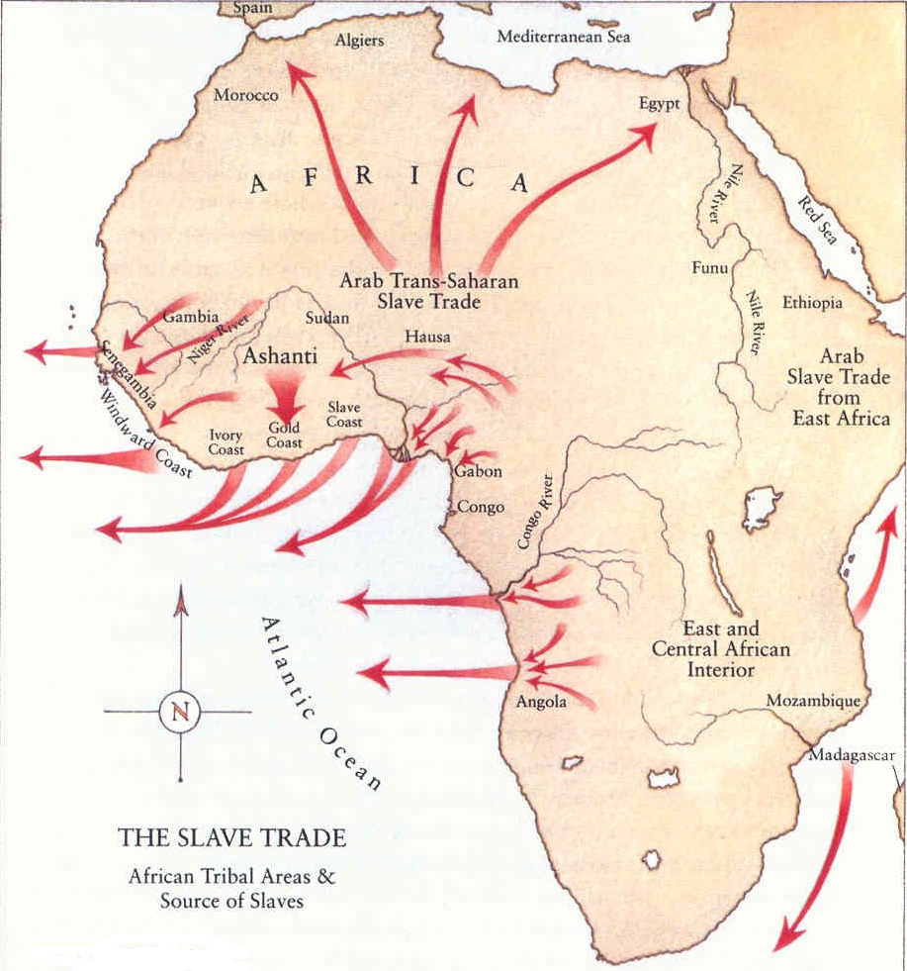

1. Growth of ivory trade stimulated the growth of slave trade. African porters to the Arabs and Arab traders to carry loads of ivory to the coast. Upon reaching the coast, the porters were sold out to traders who exported them to Arabia, Persia and India. The diagram below shows slave together with slave traders.



1. The British anti-slave trade campaigns in the Atlantic In an attempt to escape the British navy, slave traders turned to East Africa for slaves. Due to shortage of slaves for sale in Brazil and America, prices went up so that slave trade was quite profitable trade. In order to meet demand, Europeans were forced to turn to the Indian Ocean coast for slaves.
2. The French opened sugar and coffee plantations on the Indian Ocean islands such as Mauritius, Seychelles, Mayetta and the French Reunion which required slave labour. The French first obtain slaves from the Portuguese in the Zambezi valley. But high death rate due to overwork, brutality and harsh conditions led to shortage of slave labour. The French were compelled to rely on the Swahili and the Arabs in East Africa for supply of slaves.
3. The establishment of prazos by the Portuguese along the Zambezi valley demanded slave labour. The prazo holders raided slaves East and Central Africa for slaves to supply in their plantations.
4. The extension of the Oman Empire in East Africa significantly increased slave trade in Central Africa. In 1840, the Sultan of Oman, Seyyid Said transferred his headquarters to East Africa.

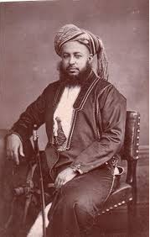 Seyyid Said

Seyyid Said moved his capital from Muscat, Oman, to Stone, Zanzibar. He started clove plantations on Zanzibar and Pemba islands. He also encouraged Arabs to develop similar plantations in the surrounding islands.

The vast farms opened on Zanzibar and Pemba islands demanded labour in form of slaves obtained from East and Central Africa.

**ORGANISATION OF IVORY AND SLAVE TRADE**

* The Arabs and the Portuguese remained at the coast. Africans from the interior brought ivory and slaves to the coast which they exchanged for beads, cloths and guns which they used to raid weaker societies for slaves. To meet the increasing demand for slaves, the Swahili-Arabs began to move into the interior to control trade. They would use guns against a village to capture slaves.
* In the interior, the Swahili-Arabs obtained ivory and slaves of strong tribes such as the Yao, the Bemba and the Lunda in Zambia.

**ROLES OF THE LOCAL CHIEFS IN THE SLAVE TRADE**

* Apart from raiding weaker societies for slaves, the chiefs obtained ivory in form of tribute from the subject chiefs. The slaves and ivory were held in one place until traders from the coast arrived for sale. Sometimes a chief himself would take the slaves and ivory to the coast for sale.

**MIDDLE-PERSONS/AGENTS OF THE SWAHILI-ARABS AND THE PORTUGUESE**

The following are the notable Middle-Persons/Agents of the Swahili-Arabs and the Portuguese and their various roles in the slave trade.

1. **The Bisa**

The Bisa supply the slaves to the Yao traders in the area around Lakes Mweru and Bangweulu which had plenty of elephants. The Yao traders sold the slaves to the Portuguese.

1. **The Nyamwezi**

The Nyamwezi supplied ivory and slaves to the Swahili-Arabs in southern Tanzania. They obtained most of the slaves from the Bemba in Zambia.

1. **The Bemba**

The Bemba were driven into slave trade for economic survival since the Bembaland had poor soils and had no minerals. Cattle-keeping was also difficult due to tsetse -flies

1. **The Chikunda**

The Chikunda raided societies in the Zambezi valley and Central Africa for slaves to supply in the Portuguese prazos.

1. **The Yao**

The Yao raided their neighbours around the Lake Malawi region for slaves to supply to the Swahili-Arabs at Kilwa.

**SLAVE CARAVANS**

The picture below shows a slave caravan and a slave trader killing a weak slave**.**



* Slaves were chained to each other in a row or tied to forked sticks called goree on the neck. Besides being chained, the roles of the slaves were to carry ivory and other goods to the coast. The caravans marched to the markets at Kilwa, Pemba and Zanzibar Islands. Slaves from Malawi were exported to Kilwa.

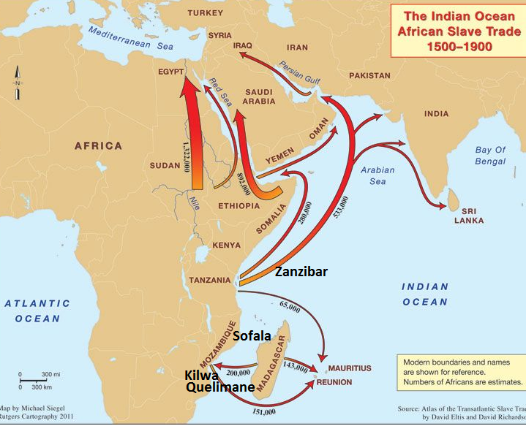

* The picture below shows the slaves crossing the Indian oceans in Arab Dhows to go the Islands on the Indian Ocean and to the Middle East.

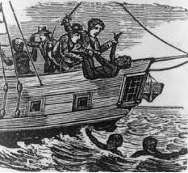

The slaves in the Arab Dhows crossing Indian Ocean

* At the market, the slave traders were charged a tax on each slave sold. To avoid paying unnecessary huge tax, the traders left the sick and the weak to die on the coastline. The slaves were mostly sold to clove and palm oil plantation owners. Surplus slaves were exported to Arabia and Persia where they were used as domestic servants or concubines.

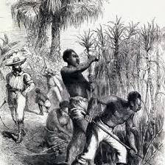 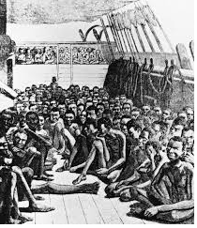

**Slaves working on plantations** **Slaves at market**

**PROBLEMS ENCOUNTERED BY THE SLAVES ON THEIR WAY TO THE MARKET AND THE COAST**

1. They could be killed by the slave traders
2. They could chained and at the same carry ivory and other goods to the markets and coast.

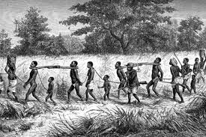

1. They could be thrown on oceans while on the way to the Middle East.

**IMPACT OF IVORY AND SLAVE TRADE ON INDEGENOUS PEOPLE**

**Positive impacts**

1. **Growth of towns**

The trade in ivory and slaves led to the growth of towns in the interior such as Karonga, Nkhota Kota and Mangochi. It also contributed to growth of towns along the East African Coast.

1. **New cultures**

It led to introduction of western and oriental cultures into the region through trade contacts and intermarriage with the Europeans and the Arabs.

1. **New crops**

It led to the introduction of new crops such as rice, maize, cassava, coconut and citrus fruits in East and Central Africa.

1. **Introduction of Christianity**

Christian missionaries began work in Malawi in order to suppress slave trade. This led to the introduction and spread of Christianity**.**

1. **Beginning of new era of commerce**

In an attempt to suppress slave trade, new traders came to Malawi. The most notable of these of these is the African Lakes Company.

**Negative impacts**

1. **Colonization of Central Africa**

The British used slave trade as an excuse to occupy Nyasaland (Malawi) and North Eastern Rhodesia (Zambia).

1. **Depopulation**

The areas affected by slave trader were depopulated by slave dealers. Apart from the thousands taken as slaves annually, many of them were killed in the process while some died on the way to the coast.

1. **Disruption of activities**

The small -scale activities such as crafts and iron working could not be practiced as people afraid of slave raiders.

1. **Destruction of African cultures**

Due to slave raids, people were not free to organize themselves and practice dances, folkroles and poems**.**

1. **Widespread famine**

There was widespread famine in the areas affected by slave trade as people were not free to work in their gardens. Slave traders preferred younger and able bodied people to the old who could not effectively work in the gardens.

1. **Ecological imbalance**

Resources such as elephants were greatly reduced in East and Central Africa over the period of ivory trade.

1. **Spread of new diseases**

Interaction between the foreign traders and Africans led to the spread of new diseases such as small pox, measles and syphilis to which Africans had no immunity.

**TOPIC 9**

**EUROPEAN OCCUPATION AND ADMINISTRATION OF CENTRAL AFRICA**

**SOUTHERN RHODESIA**

Until its independence in 1980, Zimbabwe was known as Southern Rhodesia. The country is located between Limpopo and Zambezi Rivers.

The British were interested to occupy Matebeleland, Manicaland and Mashonaland in Southern Rhodesia. See map below.

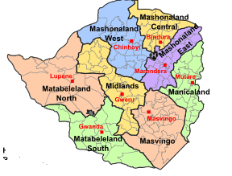

**BACKGROUND TO EUROPEAN INTERST IN SOUTHERN RHODESIA**

* The British occupation of Southern Rhodesia was due to the efforts of Cecil John Rhodes. He was born in 1853 in England. Hoping the dry climate would be good for his health, he moved to South Africa in 1870.
* By all standards, Rhodes was an imperialist who strongly believed in the superiority of British civilization. He wished the British to create a continuous territory from Cape to Cairo, and build a railway line and a telegraph to link the two cities.

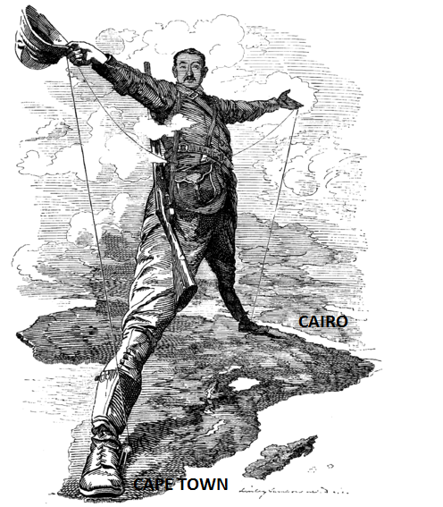

A cartoon showing Rhode’s “Cape to Cairo Dream”

**FACTORS FOR BRITISH INTEREST IN SOUTHERN RHODESIA**

The following are reasons for the British interest in Southern Rhodesia:

1. **Rhodes ‘imperialism**

* Southern Rhodesia came under British control because of Rhodes’ imperialism. Rhodes sought to colonise vast parts of Africa for the sake of British prestige. He wanted the British to occupy a continuous territory from Cape to Cairo and a railway line the two cities. He once remarked and intended.

1. **Encirclement of Transvaal**

* The British were interested in the Boer state of Transvaal for its mineral wealth. They tried to force the Boers into a federation or a customs union by preventing them access to the sea in the west.
* But the Boers looked to the area north of Limpopo River for a possible route to the sea for a port.
* Hence, the British decided to land lock Transvaal by occupying the area north of Limpopo. With no access to the sea, Transvaal would be forced to depend on British ports and railways. This would compel the Boers to accept federation of British South Africa.

1. **Mineral speculation**

* European interest in Southern Rhodesia stemmed from mineral speculation. For centuries, gold had been mined in Zimbabwe. Hopes for availability of gold in the area were raised when gold was discovered at Tati in 1871.
* In particular, Rhodes believed that the gold reef of Transvaal extended beyond Limpopo. In this way, he hoped to find a second Rand north of Limpopo. In fact, Witwatersrand was considered the “first Rand.”

**THE B.S.A COMPANY AND THE OCCUPATON OF SOUTHERN RHODESIA**

* The most powerful king in the area north of Limpopo was Lobengula. As a result, the Ndebele king became the centre of European rivalry. The Portuguese and the Boers all competed for the control of the area north of Limpopo.

**THE GROBLER TREATY, 1887**

* The Boers wanted access to the sea for a port at Beira. For this ambition to materialize, the Boers had to occupy the area north of Limpopo. Besides, the Boer wanted to control the anticipated gold in the area. Consequently, Paul Kruger, the President of Transvaal, sent Pieter and Fredrick Grobler to negotiate a friendship agreement with the Ndebele.
* Lobengula agreed to an alliance with the Boer Republic of Transvaal in July, 1887. In addition, the Boers would send a permanent Boer official at the king’s court.

**THE MOFFAT TREATY (FEBRUARY 1888)**

* This was signed by J.S. Moffat and Lobengula on 11th February,1888.
* Cecil Rhodes was determined to bring Matebeleland under the British. As a result, he sent John Smith Moffat to negotiate a treaty with Lobengula of Matebeleland. J.S. Moffat was then a British administrator in Bechuanaland.
* King Lobengula accepted a treaty on 11th February, 1888.

**TERMS OF THE MOFFAT TREATY (FEBRUARY 1888)**

1. The British would protect Lobengula against the Portuguese and the Boers.
2. Lobengula promised not to enter into any treaty with other powers without the approval of the British High Commissioner to South Africa.

* The terms of the **Moffat Treaty** especially the second term, Lobengula effectively placed his territory under ‘sphere of influence’. Similarly, it implied that the interests of the Portuguese and the Boer were dismissed in the area. Eventually, the British Government endorsed the terms of the Moffat Treaty despite protests from the Portuguese and the Boers.
* Afterwards, more mineral concession seekers came to Matebeleland. Now, Lobengula suspected ill-intentions of these whites. The analogy below undoubtedly attests to this : “Did you ever see a chameleon catch a fly? The chameleon gets behind the fly and remains motionless for some time, then he advances very slowly and gently, first putting forward one leg and then another. At last, when well within reach, he darts his tongue and the fly disappears. England is the chameleon and I am that fly.” (Adapted from History of Africa by A J Wills, 1973 p133)

**THE RUDD CONCESSION (OCTOBER, 1888)**

* Rhodes sent Charles Dunell Rudd, Rochfort Maguire and Francis Thomson to secure mineral rights in Matabeleland.
* When the British assured Lobengula of protection against Portuguese and Lobengula granted Rhodes exclusive mineral rights over his territory. In other words, the rights over all minerals and mining activities were given to Rhodes.

**TERMS OF RUDD CONCESSION (OCTOBER, 1888)**

1. The British would protect Lobengula from large-scale European settlements.
2. Lobengula would receive a monthly salary of £100 for unspecified period.
3. He would receive 1,000 rifles and 10,000 rounds of ammunition.
4. He was also promised a gunboat on the Zambezi River.

* When Lobengula discovered that he was not dealing with representatives of the British Government, he tried everything to cancel the Rudd Concession. In January, 1889, Lebengula sent his indunas, Babyana and Mshete to London to find out the connection between Rhodes and the “Great White Queen.”. However, they were deliberately delayed in Cape Town.

**FORMATION OF BRITISH SOUTH AFRICA COMPANY**

* The British Government was not willing to occupy the Matabeleland because fear of expenses. Rhodes promised to meet the administrative costs.
* When Rhodes promised to meet the administrative costs, the British Government granted Royal Charter to B.S.A Company on 29th October, 1889.
* According to the Royal Charter, the B.S.A Company was mandated to

1. Occupy the area north of the Cape Colony and Transvaal to Congo and west of Portuguese East Africa.
2. Develop mineral resources and occupy the area according to the Rudd Concession.
3. Form a police force and make rules to maintain law and order.

**THE PIONEER COLUMN**

* When the British Governmentthe Royal Charter, the B.S.A Company, Cecil Rhodes recruited whites who were interested to settle in the area between Limpopo and Zambezi Rivers. The group was called the Pioneer Column.
* It consists of 200 white settlers called the Pioneer Corps and 200BSA Company police to guard the group on its way to Matebeleland.
* Rhodes also recruited 200 Mangwato men to assist in clearing the road to look after the 117 wagons, cattle and horses.

**AIMS OF THE B.S.A COMPANY**

* The British South Africa Company had the following aims

1. to get minerals
2. to gain land for white settlers
3. to build roads and railways so as to promote trade

**BRITISH OCCUPATION OF MASHONALAND**

* The Pioneer Column sent by Cecil John Rhodes started off on 27th June, 1890. To avoid an early conflict with Matabele warriors, the Column decided to go to Mashonaland, the Pioneer Column decided to go to Mashonaland. On 12th September, 1890, the group reached present-day Harare. On 13th September, 1890, they hoisted the British flag. The settlers also built Fort Salisbury in honour of the then British Prime Minister. Hence, the settlement became known as Salisbury.
* Hoping the Europeans would protect them from the Ndebele raids, they did not resist the occupation of their land by the whites.

**BRITISH OCCUPATION OF MANICALAND**

* Rhodes was interested in Manicaland and Gazaland in the east which was territories under the Portuguese sphere of influence**.**
* Rhodes was interested in Manicaland for the following reasons

1. For its gold deposits.
2. He was also desperate for a route to the Indian Ocean so as to establish a port at Beira to serve the Company territory.
3. It was part of a strategy to completely encircle Transvaal.

* After reaching Fort Victoria, Dr Leander Jameson led a section of the Pioneer Column to Manicaland. After negotiations, Chief Mutasa signed a treaty promised British protection against outside attacks. He was to receive an annual salary of £100. In return, Mutasa granted mineral rights to the company.
* Once Rhode’s agents had left, a Portuguese force under Manuel de Souza arrived and forced the chief to ignore the treaty with the British. In reaction, B.S.A. Company forces led by Major Patrick Forces returned and arrested the Portuguese.
* Rhodes’s representative also visited Gungunyana, King of Gazaland to secure a treaty. Meanwhile, Britain and Portugal had reached an agreement known as Anglo-Portuguese Treaty on 11th June, 1891.
* By the Anglo-Portuguese Treaty, Gazaland was returned to the Portuguese while Manicaland was replaced under the B.S.A Company control. Portuguese were also given more land west of Shire River along the Zambezi Valley.

**BRITISH OCCUPATION OF MATABELELAND**

* Based on the Company’s Charter, Matabaleland was under the B.S.A Company authority. It was, therefore, a matter of time for the company to occupy the envied Ndebele territory. In a conflict that occurred, the Ndebele lost the war and their territory fell under Company control in 1893.

**B.S.A COMPANY ADMINISTRATION OF SOUTHERN RHODEESIA TO 1923**

* To avoid extra administrative costs, the British left the administration of Southern Rhodesia to the B.S.A Company. The first company Administrator was Dr Leander Starr Jameson. The Company Charter was expected to expire in 1914. After that, the country was administered by the white settlers. It was called a Responsible Government.

**NDEBELE WAR, 1893**

This was the war fought between the B.S.A Company and the Ndebele over Matabeleland in 1893.

**DISCUSS THE CAUSES AND RESULTS OF THE 1893 NDEBELE WAR**

The following were the causes of the Ndebele war in 1893:

1. The Ndebele warriors resented white intrusion into Mashonaland as their raiding ground. But the company considered itself as the protector of the Shona. The young Ndebele warriors wanted to drive the whites out of Mashonaland. However, Lobengula always restrained them hoping the company would defend his territory against the Boer and the Portuguese advances.
2. The Whites regarded the war-like nature of the Ndebele as a serious threat to their security. Due to this, Jameson was convinced that the removal of the Ndebele threat was essential for the prosperous development of Mashonaland.
3. Based on the Rudd Concession, the Company believed it had complete control of the Matabeleland. However, this was totally in contrast to the Ndebele understanding of land ownership.
4. The much speculated gold belt had failed to materialize in Mashonaland. And so the settlers hoped to find minerals in Matabeleland.
5. Some Shona chiefs stopped paying the annual tribute to Lobengula. Lobengula interpreted this as undermining his authority. In 1891 Shona chiefs Lomangundi and Chibi were killed for failing to pay the annual tribute to the Ndebele king. When the Company Administrator protested, Lobengula replied that it was none of the white person’s business.
6. In May 1983, a telegraph wire was cut off between Tuli and Fort Victoria. The Company fined Gomala, the headman, but he reported to Lobengula that the Company had taken Lobengula’s cattle. When Jameson heard about the trick, he returned the cattle.
7. The immediate cause of the Ndebele war was the Fort Victoria Incident. Bere, a Shona chief close to Fort Victoria, was alleged to have stolen Lobengula’s cattle. Lobengula sent warriors to punish him. At a meeting with Ndebele leaders, Jameson ordered the Ndebele warriors to retreat beyond Shashi River. But some Ndebele impis under Umgadan were killed for refusing to do so.

The figure below shows the Ndebele impis:

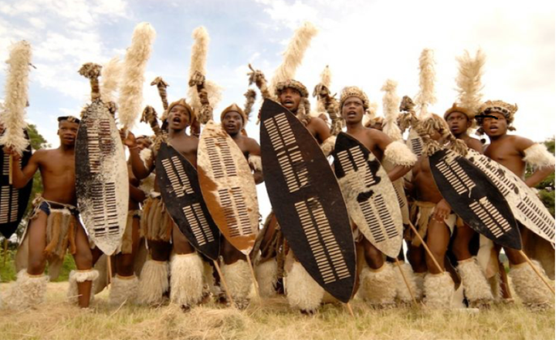

* Lobengula sent three indunas accompanied by James Dawson, a trader, for peaceful discussion with the High Commissioner in Cape Town. Upon reaching Tati, they were detained because Dawson did not explain who they were.
* In an attempt to escape, two of them were shot dead and the third escaped. When Lobengula learnt about this, he began to prepare for war. The Ndebele launched an attack on the Company at the end of September in 1893.
* Upon religious instruction that the whites would depart the country using the road to Bechuanaland, they left route unguarded. This turned out to be the strategic blunder as reinforcements and supplies to the company entered the country via the same route. As the company forces advanced towards Lobengula’s headquarters, he set his kraal ablaze and fled northwards. He died of smallpox.

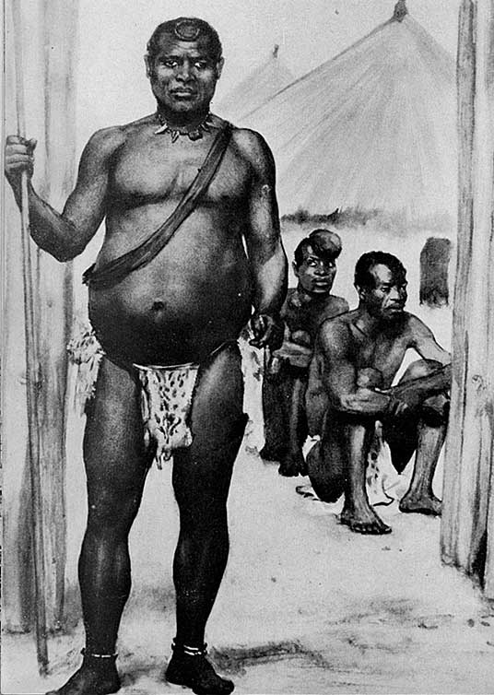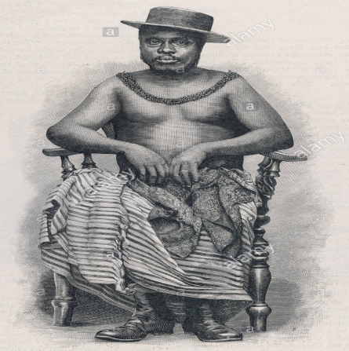Lobengula

**RESULTS OF THE NDEBELE WAR OF 1893**

1. The Ndebele were defeated and their territory came under Company control. Lobengula fled to Mozambique where he died of small pox. The Ndebele lost the war because they were poorly organized and the company used superior weapons.
2. More and more settlers from Masonaland and South Arica came to Matabeleland.
3. Lobengula’s cattle were seized by the B.S.A Company.
4. In 1894, the land along Gwaai and Shangani rivers was set aside as “reserves” for the Ndebele. The White settlers used the war-like nature of the Ndebele as an excuse to segregate and disposes them of their good land. The Ndebele had to live a distance away from the white settlers.
5. The Company recruited an African police force that consisted of the Ndebele and mostly the shone. The Shona policemen took advantage of their position to harass the Ndebele, their traditional enemies.

**THE SHONA-NDEBELE REVOLTS (1896-1897)**

* With the occupation of Matabeleland, the territory control collectively renamed “Rhodesia” in 1895.
* The Shona and Ndebele rebelled against B.S.A Company in 1896.

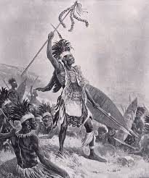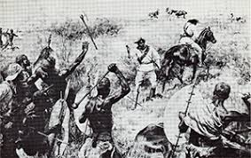

**CAUSES OF THE SHONA-NDEBELE REVOLTS**

1. The Ndebele resented their inferior position since they regred themselves as masters.
2. The Ndebele disliked the control exercised by the Shona police who made use of their new status to harass their traditional enemies.
3. The Ndebele had grievances over loss of land, cattle and sovereignty after the 1893 War.
4. Both the Ndebele and the Shona resented company administrative policies such as forced labour and taxation.

**How did the Shona religion contribute to the 1896/97 Shona-Ndebele rebellion?**

1. There was a succession of natural disasters which were religiously interpreted. For example, there was drought which led to famine in 1895; there swarm of locusts which destroyed the few crops that had survived and an outbreak of a cattle disease called rinderpest that killed a lot of cattle. As measures to stop the spread of the disease, the B.S.A Company ordered the slaughter of more livestock.

As a result of these natural disasters, the traditional priests of the Mlimo cult claimed that the disasters came about due to European presence in the Land; Mkwati, a Shona priest in Matabeleland urged Africans to expel the whites from the land. In Mashonaland, Kaguvi and Nehand, a priestess also made similar calls.

* The Ndebele revolt was encouraged by the Jameson Raid. In an attempt to overthrow, the Kruger’s government, Jameson’s forces invaded Transvaal in December 1895. But they were rounded up and imprisoned.
* The defeat of Jameson convinced the Ndebele warriors that the Whites were powerless. With most of the company forces out of the country, the Ndebele felt it was time to drive the Europeans out of their land. On 23rd March, 1896, they began to kill Europeans on farms, mines and store. The attacks soon spread to various parts of the country. The Shona also joined the revolt on 15th June, 1896.

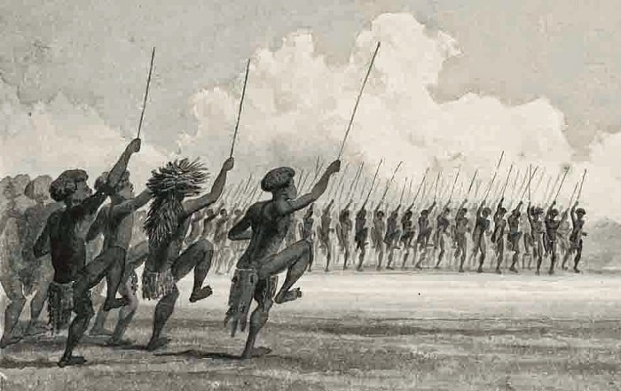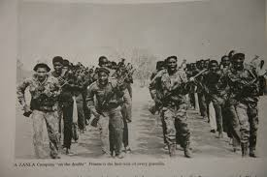

* By August end, the Ndebele had retreated to Matopo Hills where Rhodes held an indaba with the Ndebele to persuade them to stop fighting. The Ndebele demanded that the Company should disband the Shona native police. They also asked for provision of an authority to whom they could appeal.
* The outcomes of the Indaba the Ndebele and Rhodes at Matopo Hills in 1896 included:

1. The Ndebele abandoned the revolt.
2. Some indunas were officially recognized and were to be given salaries.
3. Africans were to receive food and seed supplies.
4. Rhodes promised not to employ native police in Matabeleland without the people’s consent.

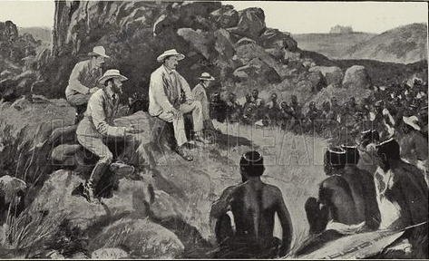

The Whites and the Indunas’s of the Ndebele at Matopo Hills

**DEFEAT OF THE SHONA**

* The Shona revolt took such a long time because the Shona were under different chiefs; the Shona had no central authority like the Ndebele which make it difficult for the company to negotiaste a peace deal with the Shona.
* The B.S.A Company defeated the Shona in 1897 because of the following reasons:

1. The European had military superiority. The Company forces had guns while the Africans used such primitive wears such as spears and axes.
2. The Ndebele withdrew from the war which allowed the whites to divert all the resources towards Mashonaland.
3. The Company forces employed a tactic that aimed to starve Africans. They destroyed African grain barns.

* By October, 1897, the Shona were clearly losing. Nahanda and Kaguvi were captured and executed. This led the end of the war.

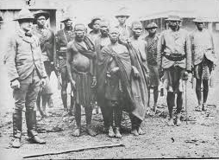

Nehanda and Kaguvi captured by the Whites

**RESULTS OF THE SHONA-NDEBELE REVOLTS**

1. In 1898, the Company introduced the reserve system in Mashonaland. The Shona who were considered submissive were also seen as a threat to white settlers. Hence, they were forbidden to build among Europeans.
2. Some Shona chiefs lost their authority.
3. The Company was criticized overseas for failing to maintain law and order. The Company was also blamed for various acts of oppression.
4. Many Africans realized that their spirits were powerless against the whites.
5. In 1898, the British introduced the Order in Council which provided for a Resident Commissioner to monitor the operations of the company.

* The country was divided into district under Native Commisioners who dealt with local matters.
* Between 1898 and 1914, W.H. Milton was the administrator.
* Matabeleland and Mashonaland were administered separately. In 1902, the two territories were merged into Southern Rhodesia.

**TOPIC 10: EUROPEAN OCCUPATION & ADMINISTRASTION OF NORTHERN REHODESIA**

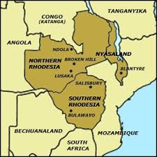

* Northern Rhodesia was bordered by Southern Rhodesia in the south and in the north-east lay Nyasaland.

**FACTORS FOR THE GROWTH OF BRITISH INTEREST IN NORTHERN RHODESIA**

The following are the factors that led to the growth of the British interests in Northern Rhodesia:

1. **Minerals**

The British were interested in copper which for many years was known to exist in the Katanga region. In fact, copper played a role in trade among the Lunda of Kazembe during the pre-colonial era. Some Europeans hoped that they could still find gold north of the Zambezi.

1. **Slave trade**

The British also wanted to suppress slave trade which was perpetrated by the Bemba, the Arabs and the Kazembe. Some Europeans hoped that they could still find gold north of the Zambezi.

1. **Agriculture**

It was believed that the area was good for arable farming.

**THE BS.A COMPANY AND THE OCCUPATION OF NORTH WESTERN RHODESIA**

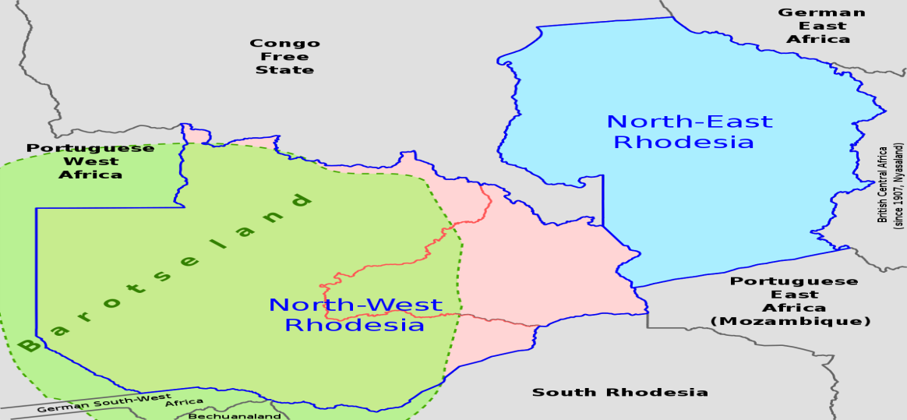

* Lewanika was the ruler of Barotseland, the North West Rhodesia when the British developed interest to occupy Northern Rhodesia.

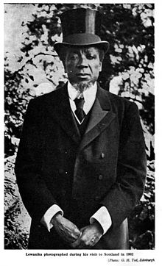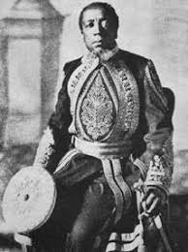 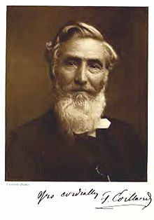

**King Lewanika Francois Coillard**

* In 1889, Lewanika wrote to Sir Sydney Shippard, the British Administrator in Bechuanaland, requesting for British protection.
* Lewanika wanted British Protection for the following reasons

1. There were constant threats from the Ndebele raids in the south.
2. Portuguese advances from Angola in the west or Mozambique in the east.
3. He feared rebellion and so he wanted to secure his position as king.
4. He was encouraged by the example of Khama, a Mangwato chief, who had accepted British protection.
5. He was encouraged by Francois Cpoillard who worked as a missionary in Barotseland.

* As the ruler of Barotseland, Lewanika was at the centre of the events that led to the occupation of North Western Rhodesia.

**THE WARE CONCESSION (JUNE, 1890)**

* This was the treaty signed by King Lewanaika and Henry Ware in June, 1889.
* The following were the terms of the Ware Concession:

1. King Lewnanika granted Henry Ware mining rights for 20 years over the Tonga country due to the delay of the British. This area was pooutside Barotseland.
2. In return, Lewinski was to receive mineral royalties and £200 per annum.

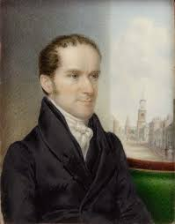 **Henry Ware**

* According to the Royal Charter, the area north of Zambezi was not limited to itspansion. For this reason, Rhodes was determined to extend Company influence in Barotseland. Therefore, he bought the Ware Concession.

**LOCHNER TREATY (1890)**

* In June, 1890, Cecil John Rhodes sent Frank Lochner to negotiate a more comprehensive treaty with Lewanika. At first Lewanika resisted because he was not sure if at all he was dealing with representative of the British. But Francois Coillard , a Catholic missionary in Barotseland convinced the king that the B.S.A Company represented the British monarch. Francois Coillard hoped the presence of the B.S.A Company would bring about stability in the area for the good of his mission work. Inaddition, Khama’s representative of Bechuanaland confirmed that the Company was indeed authorized by the Queen.

 Frank Lochner

**Terms of the Lochner Treaty, June, 1890**

1. Lewanika granted the B.S.A Company exclusive mining and commercial rights over the whole of his territory
2. The Company promised protection to Lewanika and his people from outside attacks
3. The Company promised to give Lewanika mineral royalties and a payment of £2,000 per annum
4. The Company promised that a British Resident was to come to Barotseland
5. The Company promised education and communication was to be extended to Barotseland.

According to this arrangement, Barotseland became a British Protectorate. In 1897, Robert Coryndon was sent as a British representative to Barotseland.

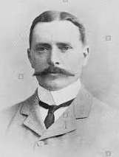 Robert Coryndon

**THE LAWLEY TREATY, JUNE 1898**

Arthur Lawley signed another Treaty with Lewanika on 25th June, 1898. It repeated most of the points in the Lochner Treaty.

**Terms of Lawley Treaty included the following:**

1. Lewanika granted powers of administration and jurisdiction or authority over most of his territory.
2. Lewanika granted the B.S.A Company exclusive mining and commercial rights over the whole of his territory
3. The Company promised protection to Lewanika and his people from outside attacks
4. The Company promised to give Lewanika mineral royalties and a payment of £2,000 per annum
5. The Company promised that a British Resident was to come to Barotseland
6. The Company promised education and communication was to be extended to Barotseland.

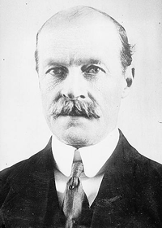 Arthur Lawley

**THE VICTORIA FALLS TREATY, OCTOBER, 1900**

In October, 1900, the B.S.A Company signed another treaty with Lewanika.

By the Victoria Treaty, most points in the Lawley Treaty were upheld. It added the following terms/clauses

1. Lewanika’s subsidy was reduced to £850.
2. The company was mandated to make land grants to Europeans for farming in Tongaland or the Ila country.

**BRITISH OCCUPATION OF NORTH EASTERN RHODESIA**



* North Eastern Rhodesia (Zambia) was inhabited by powerful chiefs such as the Bemba, the Lunda, the Arabs, and the Ngoni. Most of them resisted European attempts to occupy their territory due to their involvement in slave trade or fear of losing their political authority.
* The occupation of North Eastern Rhodesia was approached from Nyasaland. In 1889, Harry Johnston sent Alfred Sharpe to make treaties with chiefs along the Luangwa Valley and Katanga region on behalf of the B.S.A Company.

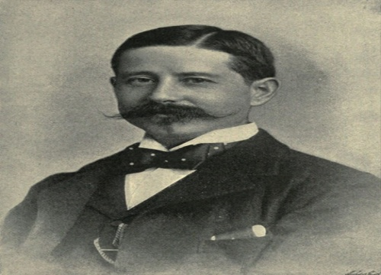 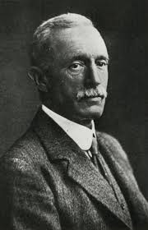

**Sir Harry Johnston Alfred Sharpe**

* Rhodes also sent Joseph Thomson to secure treaties with chiefs in the Katanga region in the same year. But he returned without meeting Msidi (Msiri), a Swahili-Arab slave trading chief, because he fell ill.

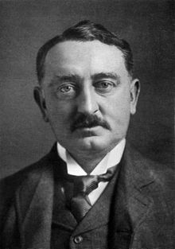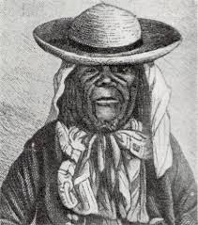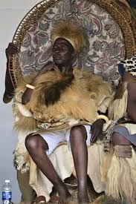

**Cecil John Rhodes King Msidi (Msiri) King Mpezeni**

* Alfred Sharpe secured treaties with a number of chiefs including Kazembe of the Lunda. However, Msidi and Mpezeni refused to sign treaties with Sharpe.
* In 1891, Belgium forces visited Msidi for treaty making but he also refused.

**THE ARAB TRADERS**

* Because they refused to give up slave trade, the Company forces led by Major Patrick Forbes attacked the Arabs. After their defeat, many their defeat, many of them escaped and sought protection among the Bemba and the Lunda chiefs where they carried on slave trade.

**THE BEMBA**

* Despite their area being under British “sphere of influence” the Bemba chiefs refused to sign treaties with Alfred Sharpe because they wanted to continue with slave trade in their area.
* To establish its authority in the area, the Company forces attacked the Bemba. Because of hostility among them, Company forces found it easy to defeat Bemba chiefs such as **Mwamba, Ponde, Kalonganjofu** and lastly *Mporokosa.*
* The Bemba chiefs failed to resist the British because of the hostility of the Company forces which used superior weapons.
* The Company then set up **Kasama** as its headquarters for the territory.

**THE LUNDA OF KAZEMBE**

* The Kazembe refused to stop slave trade. Under the 1894 arrangement, North Eastern Rhodesia was not permitted to have an army. In case of need, troops from Nyasaland Protectorate. And so, Codrington called for troops from Nyasaland under the Leadership of Alfred Sharpe in October 1899. Defeated, Kazembe fled to Belgium Congo. After negotiations, he agreed to stop slave trade and accepted British authority in his area.

**THE NGONI OF MPEZENI**

* The Ngoni of Mpezeni refused to resist the British occupation in North Eastern Rhodesia because he was afraid of losing their political authority in the area. However, Mpezeni signed a treaty with a German trader called Karl Wiese. More Europeans came to the Ngoni country.
* During the reign of Nsingu, Mpezeni’s son, the Ngoni rebelled in 1897. Again, troops from Nyasaland went and defeated the Ngoni Ngoni. Nsingu was captured and expected.

**CREATION OF NORTHERN RHODESIA**

* The area north of Zambezi was administered by Harry Johnston from Nyasaland. During this period, Johnston was dealing with slave traders in Nyasaland. It was therefore felt that he was unable to establish an effective administration in the west.
* Hence, the territory was separated from Nyasaland in 1894. The Administration of the area passed on to the B.S.A Company.
* By the **1899 Order in Council**, the British recognized Lewanika’s territory as North Western Rhodesia. The area stretching from Kafue to the western borders of Nyasaland was named **North Eastern Rhodesia**.
* **In 1911, North Eastern Rhodesia and North Western Rhodesia** were amalgamated and the country was named “Northern Rhodesia”. The country was run by an Administrator and a council of Company officials. Therefore was also a Resident Commissioner who acted as a representative of the British Government.
* In 1921, the British Government sent a commission, chaired by Lord Buxton to inquire into the position of the Company. Following recommendations of the Buxton Commission, Company rule ended in 1924, Northern Rhodesia, therefore, became a British Protectorate.

**FACTORS THAT ATTRIBUTED FOR LOWER DEMAND OF AFRICAN LABOUR IN NORTHERN RHODESIA THAN IN SOUTHERN RHODESIA**

1. There was a small population of European farmers in the country.
2. Most of the farmers concentrated on production of maize and beef which required less labour.

As the result Africans began to migrate to Katanga and Southern Rhodesia for employment.

**TOPIC 11**

**BRITISH OCCUPATION OF NYASALAND**

* Before independence, modern -day Malawi was called Nyasaland.



**What factors led to European interest in Nyasaland?**

1. **Territorial expansion**

* In the 1880s, the Portuguese to express their intention to gain control of a continuous belt of land across the interior that would link Portuguese East Africa (Mozambique) and Angola in the western coast.
* In the north, the British and the Germans sought to extend their influence over the Tanganyika/Nyasa plateau.

1. **Humanitarian factor**

The British missionaries wanted to end slave trade. As the result, the Scottish missionaries were Protestants who did not want the area where they were to come under the predominantly Catholic Portuguese. Due to Portuguese advance, the missionaries began to urge the British government to take control of Nyasaland. As a result, Captain E.C. Foot was sent in 1883 as a British consul for the country.

1. **Economic**

* In addition, the country was considered as a potential labour reservoir for the mining industry in South Africa and Southern Rhodesia. It is for this reason that Rhodes became interested in the territory despite absence of exploitable and the Lower Shire had good soils for the production of cotton for the textile industry in Britain. Such reports attracted Europeans to come to start plantation agriculture in the Shire Highlands.

**ANGLO-PORTUGUESE RIVALRY OVER NYASALAND**

* In 1882, an armed Portuguese expedition arrived in Lower Shire and ordered chiefs in the area to surrender their authority to the Portuguese Government. They hoisted a Portuguese flag at Pinda’s village on 12th May, 1882.
* Due to the growing Portuguese influence, the Scottish missionaries appealed to British government to occupy the area so as to protect their interests. In response, Captain Foot arrived at Blantyre as British Consul in 1883.
* In 1884, Lieutenant Cardozo visited the Shire Highlands and signed treaties with a number of chiefs such as Mponda.
* Between 1884 and 1886, the African Lakes Company secured treaties with chiefs in the north.
* In 1888, Portugal produced a map that showed the Shire Highlands was in the Portuguese “sphere of influence”.
* In April 1889, Daniel Rankin discovered Chinde mouth on the Zambezi so that the British goods would easily enter Nyasaland without Portuguese interference. All along the Portuguese could block British travels inland or withhold goods.
* Towards end of 1889, Major Serpa Pinto led a Portuguese expedition to the Lower Shire to make further treaties with chiefs in Nyasaland. He secured 25 treaties with chiefs in the area but British missionaries and traders rejected these claims.

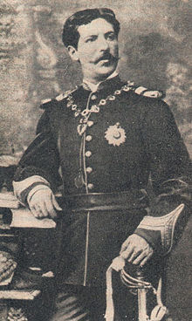 Major Serpa Pinto

* The British took long time to occupy Nyasaland because they did not want to spend extra costs on the administration of the territory.
* The two reasons why the British decided to occupy Nyasaland included

1. They were not prepared to lose the area to the Portuguese.
2. Rhodes offered to support Johnson with an annual £10,000 towards the administration of the territory.

* Then Harry Johnson signed treaties with chiefs along western side of Lake Malawi. The treaties were aimed at ending slave trade and to establish British authority in the region. Jumbe agreed to a treaty with the British after being warned of Portuguese advance in the south and German activities in the north.
* He also signed treaties with the Tonga chiefs around Bandawe who viewd the British as allies against the Ngoni raids. The Tonga therefore welcomed British authority in their area.
* He also signed a treaty with Mlozi in Karonga.
* In the South, he signed a treaty with the Yao chief Mponda. In all these treaties, it was stated that the chiefs would not surrender their land to other colonial power without British approval.
* In 1889, Johnson sent Buchanan to order Pinto to withdraw from the area but he refused. Then Buchanan declared a British Protectorate over the Kololo country and erected the Union Jack. Pinto attacked the chief. Amidst, Portuguese protests, he declared a British Protectorate over the Shire Highlands on 21 September, 1889.
* The events forced the British to issue an ultimatum on 11 January, 1890 to the Portuguese beyond the Ruo River and from Mashonaland. On orders from Lisbon, Pinto pulled out of the Kololo country.
* Meanwhile, negotiations regarding territorial boundaries were under way between Portugal, Germany and Britain. By Anglo-German Agreement on 1 July, 1890, the territory north of Songwe River and north-eastern shores of Lake Nyasa went to Germany.
* The Anglo-Portuguese Agreement was signed on 11 June, 1891. As a result, the confluence of Shire and Ruo Rivers marked the southern boundaries with the Portuguese territory. Portugal lost Manicaland to the British. As compensation for the loss of much territory, Portugal was given more territory in the Zambezi Valley.

**THE CHILEMBWE UPRISING, 1915**

* John Chilembwe was born in 1870 to Kaundama, a yao and his mother was Nyangu was a Mang’anja. He did a village school at the Blantyre Mission in Chilomoni.
* He became a house servant of Joseph Both who started Zambezi Industrial Mission at Mitsidi. Joseph Booth was a Baptist Missionary.

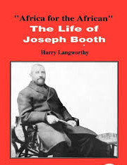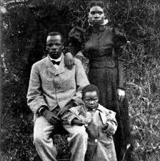

**Joseph Booth John Chilembwe**

* In 1897, Joseph Booth took John Chilembwe to the United States of America where he attended the Virginia Theological Seminary at Lynchburg with the support of the African-Americans of the National Baptist Convention. He was ordained as a Baptist Church Minister in 1899.
* While in America, Chilembwe was exposed to white racial segregation against the African-Americans. It was here that he was also influenced by the radical ideas of people such as Marcus Garvey and Booker T. Washington.
* He established Providence Industrial Mission at Mbombwe in Chiladzulu in 1900 after he came back from the United States of America. This mission located near the A.L Bruce estate whose manager was William Jervis Livingstone.
* William Jervis Livingstone was cruel and a violent racist who made Africans to do Thangata on his farms, could whip Africans for no reasons, disliked Africans who attended church or sent their children to school., forbade the constructions of African churches which believed taught African subversive ideas, African s not being allowed to cut tress and bamboo for building, being forbidden to wear hats or shoes in the presence of Europeans.
* Despite the ban, Chilembwe went on to build churches and schools deep into the A.L.Bruce estate. In reaction, W. Livingstone ordered the demolition of Chilembwe’s churches and schools

**CAUSES OF CHILEMBWE UPRSING OF 1915**

1. **Resentment of colonial administrative polices**

Africans resented the heavy tax and how it was collected. Harsh methods were used to collect tax. People who failed to pay tax, their crops were being uprooted, huts burnt down or wives held hostages until husband paid the tax.

1. **Economic discontent**

Africans hated Thangata method of working on the European estates. Africans living on European bought land had to pay rent in form of labour to European estate owners**.**

1. **Land shortages**

* There was land pressure which was increased by the influx of the Lomwe migrants from Mozambique between 1912 and 1913. African discontent increased with the famine of 1913.

1. **Hostility between Chilembwe and W.J.Livingstone**

* Poor relationship between Chilembwe and AW.J.Livingstone contributed to the rebellion. Chilembwe protested against Livingstone’s ill-treatment of Africans. Chilembwe protested against the land policies which were blamed for economic hardships in the area. William Jervis Livingstone was cruel and a violent racist who made Africans to do Thangata on his farms, could whip Africans for no reasons, disliked Africans who attended church or sent their children to school., forbade the constructions of African churches which believed taught African subversive ideas, African s not being allowed to cut tress and bamboo for building, being forbidden to wear hats or shoes in the presence of Europeans.

1. **Influence of foreign political ideas**

Chilembwe’s association with Joseph Both and his experience in the US exposed him to radical ideas of equality of all races and freedoms. Back home, he influenced his friends who later supported him during the rebellion.

1. **Influence of millennial messages and prophecies**

Chilembwe and other Africans were influenced by messages and prophecies. For example the Watch Tower Movement and Bible Tract Society of Elliot Kamwana preached about the coming “New Age” in 1914. They preached that the world would come to an end in that year. Colonial oppression would also cease and a new age of prosperity would begin. Thus when the First World War broke out in 1914. This prophecy appeared real to many people.

1. **African recruitment in the First World War.**

Chilembwe was strongly opposed to the idea of Africans fighting and dying in a war that was not theirs. As a result, he protested against the recruitment of Africans in his letter that was published in the Nyasaland Times. The stated ***“Let the rich men, bankers, titled men, storekeepers, farmers and landlords go to war and get shot. Instead the poor Africans who have nothing to own in this present world, who in death leave only a long line of widows and orphans in utter want and dire distress are invited to die for a cause which is not theirs….. We leave all for the consideration of the Government, we hope in the Mercy of the Almighty God that someday things will turn out well and that Government will recognize our indispensability, and that justice will prevail”.*** An excerpt of Chilembwe’s letter to the Nyasaland Times, 25 November, 1915 (reproduced in G, A Shepperson and T.Price, Independent Africa, Edinburg, 1958 pp.234pp)

**THE COURSE OF THE CHILEMBWE’S UPRISING, 1915**

* ChiLembwe was forewarned by his church member; a typist at King’s African Rifles in Zomba that government planned to arrest and deport him to Mauritius. He further disclosed that the government would attack Mbombwe on 24th January, 1915.
* Chilembwe quickly organized a group of his supporters which included John Gray Kufa, Wallace Kaduya, Andrack Jamali, Duncan Njilima, Thomas Lulanga, Hugh Mataka, Stephen and Andrew Mkulichi. It was agreed to attack first before the government.
* As planned, they attacked Magomero where they killed W.J. Livingstone on 23rd Januuary, 1915. As Chilembwe instructed, women and children were not harmed. Another group attacked Mandala (the African Lakes Company stores) to obtain new guns and ammunitions.
* They also attacked Mwanje and set Nguludi Mission Station in Chiladzulu on fire. In Ntcheu, the rising failed because the government learnt of the plan in advance.
* The following day, government forces began to suppress the rebellion. Within two weeks, order was restored in the Shire Highlands
* **Reasons why Chilembwe uprising was a failure:**

1. Chilembwe lacked the support he hoped to receive. He expected support from discontented Africans on the estates, relatives of the soldiers killed in the First World, educated and the chiefs
2. They had military inferiority. They lacked ammunition.
3. The revolt was poorly and hastily planned.

* Eventually, Chilembwe escaped and was killed near the Mulanje- Mozambique border on 3rd February, 1915.

**RESULTS OF THE CHILEMBWE’S UPRING OF JANUARY-FEBRUARY, 1915**

1. **Loss of lives.**

Chilembwe and a good number of Africans were killed. Only three Europeans were killed by Chilembwe’s men.

1. **Banning of Providence Industrial Mission**

Chilembwe’s church called the New Jerusalem at Magomero was burnt down. The colonial administration banned the P.I.M. It was only reopened in 1926 by Daniel Malikebu.

1. **Appointment of a Commission of Inquiry**

A commission of inquiry was appointed to investigate the cause of the revolt. The commission blamed the revolt on mission -educated Africans and Joseph Booth. It therefore recommended the need to monitor Protestant missionaries and their schools.

1. **Government participation in African education**

The colonial administration began to participate in African education**.**

1. **Improved African welfare**

The administration introduced Africans on Private Ordinance in 1915 which abolished Thangata system.

1. **Deportation of missionaries**

Suspected missionaries such as Mr. Cockerill and Miss Hollis of Church of Christ and Elliot Kamwana were deported from the country. The Watch Tower Movement was banned two years after the revolt.

1. **Re-organisation of villages**

For easy monitoring and prevention of similar revolts, African huts in the area were grouped into units.

**SIGNIFICANCE OD CHILEMBWE’S UPRISING OF 1915**

1. It became a symbol of later resistance against colonial rule. The rising marked a new era in the ant- colonial struggle in the country.
2. Chilembwe was raised to the status of a legendary figure as myths developed around his name.
3. Africans believed that they could still liberate their country, but under new approaches as opposed to radical means.

**LABOUR MIGRATION FROM NYASALAND DURING COLONIAL ERA**

* From 1903, Nyasaland had become the centre for labour competition for the mines in South Africa, the Copper belt, Katanga and Sothern Rhodesia. Apart from the mining industry, the migrant labourers worked in the plantations in Sothern Rhodesia.
* Due to absence of mines and factory industries, Nyasaland became a source of cheap labour for her neighbouring countries.
* The plantation agriculture could not afford to employ the growing population of Africans.
* Labourers from Nyasaland were preferred in Southern Rhodesia and South Africa because they accepted lower wages. Secondly, unlike the natives who often deserted, foreign labourers could not escape because of long distance from their home
* By 1907, the following agencies were established to recruit labourers from Nyasaland

1. Witwatersrand Native Labour Association (WENELA) recruited labourers for the mines in South Africa.
2. Northern Rhodesia Native Labour Association (NRNLA) obtained recruits for the Copperbelt.
3. Rhodesia Native Labour Bureau (Mthandizi) recruited labourers for the mining industry in Southern Rhodesia
4. Robert Williams and Company supplied labour for the Copperbelt and Katanga.

These agenises recruited labour mostly from Mzimba, Nkhata Bay, Dowa and Ntcheu districts.

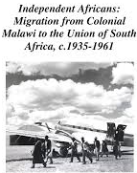

**Reasons for labour migration from nyasaland during colonial era**

1. Africans who lost their land as a result of land alienation went abroad seeking employment.
2. After the introduction of tax, most male adults migrated to neighbouring countries to raise money for tax.
3. Mission school graduates went to neighbouring countries for employment opportunities. Having been the first to benefit from western education, the Tonga left in large numbers to seek employment abroad.
4. Some of the Africans viewed it as a mark of new status in the rural society since they brought goods such blankets, bicycles, shoes and suits. Some of them spoke foreign languages.

**PROBLEMS FACED BY LABOUR MIGRANTS IN WORK MINES AND PLANTATIONS**

1. Africans were provided with poor food and accommodation.
2. They were also paid low wages.

* Despite that there being paid low wages, the wages were better in Sothern Rhodesia than in Nyasaland ad Northern Rhodesia. As a result, there developed mass labour migration from Nyasaland to neighbouring countries and South Africa.

**IMPACT OF LABOUR MIGRATION**

1. **Source of income**

The migrant workers sent money to their families and relatives.

1. **Spread of foreign goods.**

The returned migrant workers brought foreign goods such as blankets, sewing machines and musical instruments like accordions and gramophone.

1. **Diversification of rural economies**

Upon return, some migrant workers started small-scale businesses such as maize mills and grocery shops

1. **Infrastructure**

Good houses made of bricks and iron sheets were built in the villages.

1. **Stagnation of rural economies**

Activities such as farming were affected as most active male adults went to work abroad. This implied that such works were done by women, children and old people.

1. **Spread of poverty**

Some migrant men did not send money or clothes home. Poverty was also contributed by the reduction of farming at family level.

1. **Social disorder**

It led to the emergence of a class of matchona or people who did not return home. This increased immorality and marriage breakages. Some unfortunately returned and found their wives either remarried or with other men’s children.

1. **Political consciousness**

Due to poor work conditions, Africans organized strikes, demonstrations and boycotts. They also joined labour unions in the mines where they gained important skills for organized collective bargaining. Back home, they employed the skills and radical methods they had acquired in the mines to demand improvement of the colonial policies. For example Levi Ziliro Mumba was instrumental in organizing Native Associations.

**TOPIC 13: THE CENTRAL AFRICAN FEDERATION**

* A federation is the union of states under one national government
* Central African federation was the amalgamation of Northern Rhodesia, Southern Rhodesia and Nyasaland under the British government.

**DEVONSHIRE DECLARATION (1923)**

* In 1923, the British Government issued a statement that outlined its stand on the colonial policy. It stated that any discussion regarding a closer union must consider the interests of Africans as paramount. The settlers felt that their interests would best be served by amalgamation of Northern Rhodesia and Southern Rhodesia.

**HILTON YOUNG COMMISSION (1930)**

* In 1929 the British Government appointed a commission of inquiry chaired by Sir E Hilton Young to look the possibility of a closer union of British East and Central African colonies.

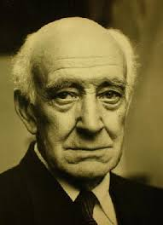 Sir E Hilton Young

* It found out that a federation of East and Central Africa would not be possible due to communication problem. In addition, the dominant native population would work against the minority whites.

**PASSFIELD MEMORANDUM (1930)**

* The British Secretary of State for Dominion Affairs published a memorandum in 1930.
* It emphasized the principle of considering the interests of Africans paramount.
* In other words, it repeated the principles of the Devonshire Declaration. Alarmed, the white settlers became more determined in support of amalgamation.

**THE FIRST VICTORIA FALLS CONFERENCE (1936)**

* In 1934, Sir Godfrey Huggins became the Prime Minister of Southern Rhodesia. He promoted the question of amalgamation. Two years later, a meeting of representatives from the two Rhodesias was held near Victoria Falls. The delegates supported the amalgamation of the two Rhodesias

**THE BLEDSLOE COMMISSION (1939)**

* In reaction, the British Government appointed a commission of inquiry, chaired by Viscount Bledsloe, to find out the possibility of a closer union of the two Rhodesias and Nyasaland. It found that Africans in Northern Rhodesia were strongly opposed to the federation.
* In its report, the commission rejected amalgamation and federation altogether. Among others, it recommended the establishment of an inter-Territorial Council which would coordinate government services and assess the economic needs of three territories.

**THE SECOND VICTORIA FALLS CONFERENCE (1949)**

* The British Government persuaded Sir Roy Welensky to drop the policy of amalgamation on the grounds that I would not be practical.
* It suggested a federation of the three territories, Northern Rhodesia, Southern Rhodesia and Nyasaland.
* At a conference held in February, 1949 near the Victoria Falls, the representatives of the two Rhodesia and Nyasaland unanimously favoured a federation of the three territories**.**

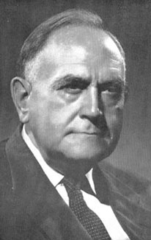 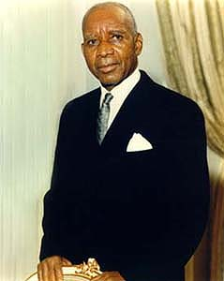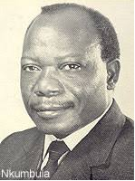

**Sir Roy Welensky Dr Hastings Kamuzu Banda Harry Nkhumbula**

* Africans in London such as Dr Hastings Kamuzu Banda of Nyasaland and Harry Nkumbula of Northern Rhodesia protested against the federation in the same moth, February, 1949.

**THE THIRD VICTORIA FALLS CONFERENCE (1951)**

* The Africans from all three territories rejected the federation. Nyasaland was represented by Chief Mwase, Clement Kumbikano and Mr Edward Gondwe.
* At the conference Mr James Griffiths, the British Colonial Secretary, was convinced that the federation would not work without African support.

**LONDON CONFERENCES (1951-53)**

* James Griffiths was replaced by Mr Oliver Lyttelton when the conservative Party took over government in October, 1951.
* by Mr Oliver Lyttelton’s view was that if Africans did not see the as=dvantages of the fedration, then it had to be imposed on them. The Nyasaland African Congress to the conference boycotted the talks in London. In Nyasaland, a Supreme Council of Chiefs was set up to direct the campaign aginst the imposition of the federation. As a result, disturbances broke out across the country in April, 1953. African ressistance included strikes, boycotts and non-payment of taxes etc.
* The following montyh, six chiefs were sent to London to protest against the imposition of the federation : M’mbelwa and Katumbi from the North; Gomani 11 and Maganga from the centre and Kuntaja and Somba from the South. Despite African opposition and protests, the Federation was at last imposed in October, 1953. Its capital was Salisbury(Harare)

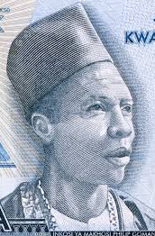 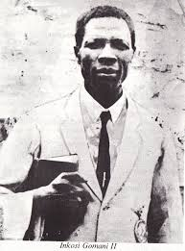 G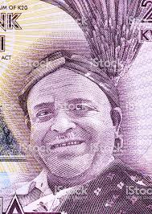

**Gomani II Gomani II**  **M’mbelwa II**

* The head of the Federal Government was the Governor General who represented the British Queen.
* The Federal Government was responsible for defense, customs and immigration, communication, non-African education, public health and European agriculture.
* The Federal Executive was presided over by the Prime Minister.
* The first Prime Minister of the Federation of Rhodesia and Nyasaland imposed in 1953 was Sir Godferey Huggins. He was succeeded by Roy Welensky in 1956.
* The Prime Minister appointed cabinet members from the members of the Legislative Assembly. Each territory consisted of an Executive Council headed by a Governor and a Legislative Council. The individual arrangements were responsible for African Affairs on agriculture, land, education, local government, housing, mining and constitution.

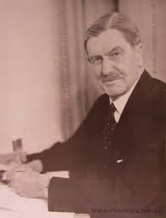

Sir Roy Welensky Sir Godfrey Huggins

The map below shows the boundary of Nyasaland during federation.

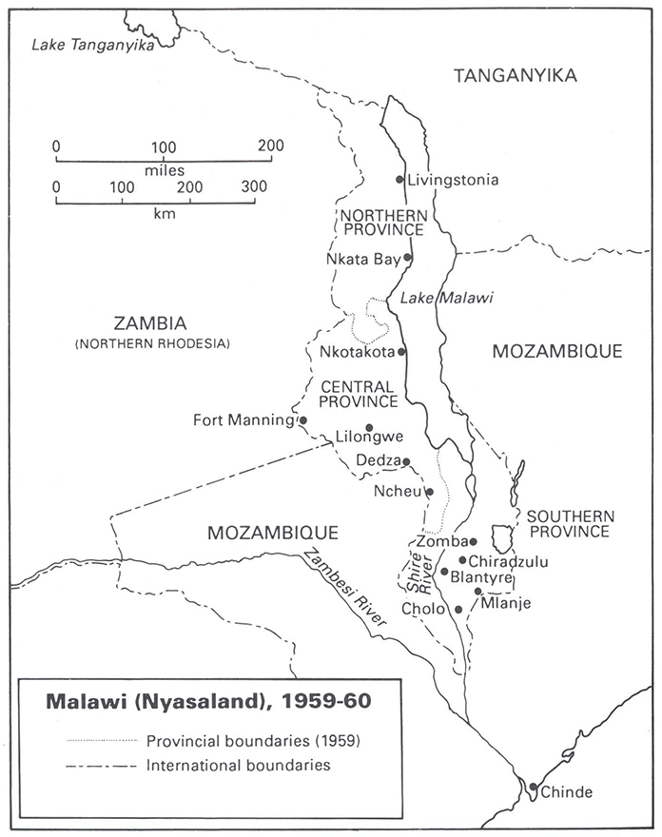

**REASONS FOR THE IMPOSITION OF THE FEDERATION OF RHODESIA AND NYASALAND**

**Political reasons**

1. The federation would create a strong sphere of influence in Central Africa. This would prevent Southern Rhodesia from moving towards the Boer-controlled South Africa**.**
2. The federation would preserve and strengthen British civilization and culture in the region.
3. It would serve as a model for the establishment of similar unions in other areas such as East Africa.
4. It would promote partnership of races to counter South Africa’s apartheid. Africans and non-Africans would work side by side.
5. It would improve British administration and control of the region by harmonizing its policies on research, customs, currency, trade, defence and communication.

**Economic reasons**

1. It would promote even development of the region
2. The federation would make the region independent and self-sufficient than it had bee,
3. The integration of the industries of Southern Rhodesia, the copper of Northern Rhodesia vibrant and stable economic union in the region. This would attract investment and expand the market.

**REASONS FOR AFRICAN OPPOSITION TO THE FEDERATION OF RHODESIA AND NYASALAND**

1. Africans in Nyasaland and Northern Rhodesia feared that the racial segregation policies would apply to their countries.
2. Africans thought the federation would delay self government.
3. Africans would be marginalized under the federation.

* African discontent continued throughout the period, the federation was in force.
* In 3rd March, 1959, Sir Robert Armitage declared state of emergency in Nyasaland. This was a result of countrywide strikes, riots and demonstrations in Nyasaland.

**MOCKTON COMMISSION (1960)**

* This the commission sent by the British Government to examine the future of the Central African Federation.
* It found out that Africans were strongly opposed to the Federation. It recommended that any country should be allowed to secede if it wished so.
* The Federation was official dissolved on 31st December, 1963 when Dr Hastings Kamuzu Banda withdrew Nyasaland from the federation.

**TOPIC 14: THE AFRICAN INDEPENDENT CHURCHES IN MALAWI**

* These were churches that were founded and led by local Africans who broke away from the missionary -controlled churches.
* These churches drew their membership largely from the uneducated masses.
* These are churches whose form of Christianity tolerated or compromised local cultures and customs.

**FACTORS FOR THE FORMATION OF AFRICAN INDEPENDENT CHURCHES**

1. They were established to serve the interests of the Africans. They wanted to tolerate some African cultures such as polygamy, dances, beer drinking, and birth and death rites.
2. Education provided by the missionaries enabled Africans to develop a critical mind. They began to question some church practices and to form their own churches.
3. There were misunderstandings on church doctrines especially regarding the interpretation of biblical doctrines such baptism, day of warship, marriage and church discipline.
4. Dissatisfaction with the long period for someone to be baptized or ordained.
5. Slow decentralization of leadership in the missionary controlled churches. The European missionaries were unwilling to entrust leadership of the church to Africans.
6. Discriminatory practices in the church contributed to dissatisfaction with the European missionary churches. The Livingstonia Missionaries for example favoured Bandawe more than Chifira.
7. Dissatisfaction with the education offered by some mission especially the Dutch Reformed Church.

**EXAMPLES OF AFRICAN INDEPENEDENT CHURCHES**

1. **PROVIDENCE INDUSTRIAL MISSION**

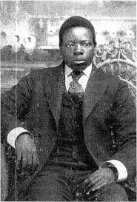 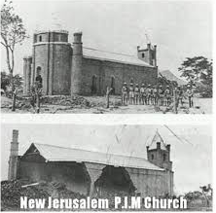

John Chilembwe PIM before and after Chilembwe’s uprising

* He established Providence Industrial Mission at Mbombwe in Chiladzulu in 1900 after he came back from the United States of America.
* In his sermons, John Chilembwe emphasized the values of self-help and hard work. Later he used the pulpit to denounce colonial policies on land, labour tenancy or thangata and expoitation on plantation estates.
* He built churches and schools around the area.
* In 1913, he completed a large church building at Mbombwe which was named the New Jerusalem
* The colonial administration banned the P.I.M. The PIM was banned until it was only reopened in 1926 by Daniel Malikebu.

1. **THE WATCH TOWER MOVEMENT**

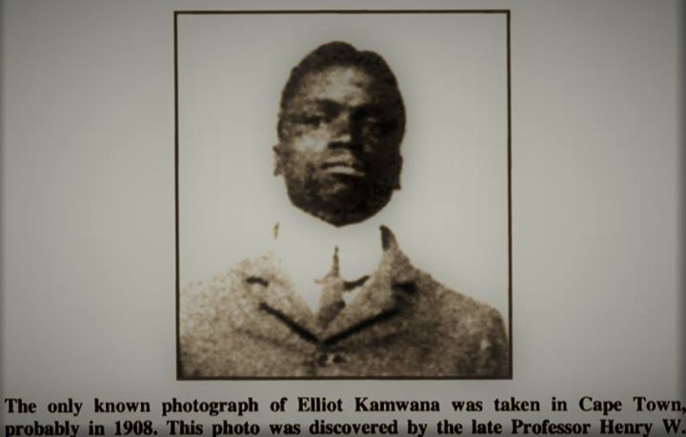

**Eliot Kamwana**

* Elliot Kamwana attended Bandawe Mission School 1898 and 1901. He broke away from the Livingstonia due to dissatisfaction over the introduction of fees and baptism. He was convinced that true baptism was by immersion and not sprinkling as conducted by the Presbyterians.
* He later travelled to South Africa as a migrant labourr where he was associated with Joseph Booth and the Adventists. It was here that he came under the influence of the teachings of Charle’s Russel’s Jehovah’s Witnesses.
* Upon his return to Nyasaland, Eliot Kamwana established the Watch Tower Movement in his home area Bandawe. It preached a millennial message of the
* of Christian would end colonial rule and abolish and abolish the hut tax.
* Kamwana had baptized some 10,000 converts around the area.
* In reaction to his preaching and his followers refusal to enter the service of the KAR, the colonia administration deported him to Mauritius on the Indian Ocean. Despite his exile, his church spread surreptitiousiy to Northern Rhodesia and the Belgian Congo .Kamwana returned in 1937 and later opened the Mikaele Church in Nkhata Bay.

1. **THE LAST CHURCH OF GOD AND HIS CHRIST**

* The church was started in 1925 by Jordan Msumba in Nkhata Bay .Among others,his church emphasized quick baptistism and tolerated porygamy .Msumba later went to Karonga where he infruenced a Nyakyusa named Ben S .Ngemela.The church there was known as the Ngemera church.Blackman’s church of Africa
* The church was established in 1933 by Yesaya Zerenji Mwase. Mwase was born about 1870 at Chikuyu in Nkhata Bay district. He was aproduct of the Living stonia Mission School. Although he completed his theological training in 1914.
* On 26th September,1933 he broke away from the Livingstonia Mission and founded the Blackman’s Church of Africa {Mpingo wa Afipa wamu Africa}. He was dissatisfied by strict discipline in the Livingstonia which led to delays in ordination and admission of new members in to the church.
* Besides the Tumbuka hymms he composed, Mwase was active in politics and writing. He was a member of the North Nyasa Native Association and he wrote a history of the Tonga.
* He also established the West Nyasa Blackman’s Educational Society.

1. **EKLESIA LAWANANGWA**

* Charles Chidongo Chinula did his early education at Hora and Ekwendeni.
* From there, he went to Livingstonia before becoming a teacher at Loudan Mission.
* After the First World War, he went for theological training and was ordained on 11th October, 1925.
* In 1930 he was suspended for involvement in a sex scandal but he was later restored.
* Chinula believed in reconciliation of Chritianity and traditional culture. For example he secretly encouraged his pupils to practice traditional dances while teaching at Loudan.
* He later broke off from the Livingstonia Mission and founded Eklesia Lawanangwa (Free Church) on 11th July, 1934.
* Chinula did not like the manner in which missionaries treated Africans. In addition, the Church refused to admit into the church children of drunkards and polygamists.
* In 1935, his church became part of the Blackman’s Church.
* He also established the Sazu Home Mission a few kilometers from Edingeni in Mzimba. He also built schools after Dr Hastings Kamuzu Banda provided an annual financial contribution towards his schools
* Some Tumbuka hymms were composed by him.
* He was influential in the Mombera Native Association and he was also one of the founders of the Nyasaland African Congress.

1. **AFRICAN METHODIST EPISCOPAL CHURCH**

* Hannock Msokera attended Livingstonia Mission School in Kasungu.
* In 1916 he went to South Africa as a migrant worker labourer where he joined the African Methodist Episcopal Church.
* He was not happy with the education offered by the Dutch Reformed Church mission schools.
* In 1924 Msokera started a branch of the African Methodist Episcopal Church at Kaning’a in Kasungu. He also opened schools where western education and technical skills were offered.

1. **ANA A MULUNGU CHURCH**

* The Church was started by Wilfred Gudu of Thyolo district. Gudu was a Seventh Day Adventist at Malamulo. But he left the church to establish his own church called Ana a Mulungu. He encouraged his followers not to pay tax to the colonial government.